**Master Thesis**



**Faculty of Engineering, University of Denmark**

**Advanced Human Presence Detection Using Thermal Sensing: A Novel Approach Beyond PIR Sensors**

**Submitted by**

Hamza Rashid

**University Supervisor**

Mohamed Kheir

**Compony Supervisor**

Walid Mansour

# Abstract

# Acknowledgement

**Mohamed Kheir**, Professor, SDU Center for Industrial Electronic (CIE)

My supervisor at SDU.

**Walid Mansour**, Project Manager, Wygwam

My supervisor at Wygwam.

I would like to express my heartfelt gratitude to all those who supported and contributed to the successful completion of this thesis project.

First and foremost, I extend my sincere thanks to **Walid Mansour**, my industrial supervisor at Wygwam, for his continued guidance, valuable feedback, and for providing a collaborative environment that allowed me to explore and apply real-world solutions throughout the project. His mentorship was instrumental in shaping both the technical and practical direction of this work.

I am equally grateful to **Mohamed Kheir**, Lecturer at the Center for Industrial Electronics (CIE), University of Southern Denmark (SDU), for his academic supervision. His critical insights, encouragement, and technical support played a key role in refining the research objectives and ensuring the scientific rigor of the thesis.

I would also like to thank the entire teams at Wygwam and SDU-CIE for fostering an engaging and supportive environment, where innovation, experimentation, and academic freedom could thrive. Their openness and collaboration significantly enhanced my learning experience.

Finally, I acknowledge the use of generative AI tools during the preparation of this report specifically for grammar refinement and rephrasing. All conceptual development, experimentation, and conclusions drawn, however, are entirely my own.

This thesis represents not only an academic milestone, but also a valuable personal journey that was made possible through the shared knowledge, time, and encouragement of everyone mentioned above.

Table of Contents

Abstract ii

Acknowledgement iii

List of Tables vii

List of Figures viii

Nomenclature 9

1. Introduction 10

1.1. Background and Motivation 10

1.2. Literature Review 12

1.2.1. Human Presence Detection 12

1.2.2. Occupancy Detection Technologies 12

1.2.3. Machine Learning Approaches for Thermal Sensor Data 14

1.2.4. Summary of Key Papers 16

1.2.5. Identified Gaps 16

1.3. Problem Statement and Objectives 17

Objectives 17

2. Methodology 18

2.1. Description of the Hardware 18

2.1.1. Why Thermal Sensing? 18

2.1.2. Introduction to Thermal Sensing 20

2.1.3. Sensor Working Principle and Performance 21

2.1.4. Comparative Analysis of Thermal Sensors for Human Presence Detection 22

2.1.5. Selection of Microcontroller 24

2.2. Data Collection 25

2.2.1. Mounting Angles and Considerations 25

2.2.2. Controlled Environment Considerations and Standards decided 27

2.3. Preprocessing and Data Augmentation 29

2.3.1. Hand Crafted Feature Extraction 29

2.3.2. Data Augmentation Techniques 30

2.3.3. Background Removal for Static Heat Suppression 30

2.4. Machine Learning Models 33

2.4.1. 1D CNN Model 33

2.4.2. 2D CNN Model with Feature Engineering 34

2.4.3. Hybrid Model (CNN and LSTM) with Feature Engineering 35

2.4.4. Temporal CNN with Feature Engineering 35

2.4.5. Multi-Layer Perceptron (MLP) as a Benchmark Model 36

2.5. Model Training and Validation 36

2.6. Deployment on Raspberry PI 37

2.7. Performance Validation 39

2.7.1. PIR Sensor Setup and Measurement 39

2.7.2. Thermal Sensor-Based Detection and Logging 40

2.7.3. Test Scenarios and Rationale 41

2.7.4. Performance Metric Development 41

2.8. Model Adaptation and Deployment on ESP32-S3 42

2.8.1. Model Quantization and Deployment Workflow 43

2.8.2. Sensor Integration with ESP32 44

3. Results and Analysis 44

3.1. Training and Validation Results 44

3.2. Model Performance on Test Data 45

3.3. Model Performance Comparison 47

3.4. Real-Time Background Adaptation and Static Heat Suppression 48

3.5. Real Time Inference Results on Raspberrypi 49

Scenario 1: No Heater – Open Room Environment 50

Scenario 2: Heater and Plumbing Heat – Washroom Environment 50

Scenario 3: High Heat Source with Background Removal Concept 50

3.6. Performance Evaluation of Presence Detection Systems 52

3.6.1. Detection Responsiveness in Entry/Exit Scenarios 52

3.6.2. Detection Reliability in Static Presence Scenarios 53

3.6.3. False Trigger Analysis in No Presence Scenarios 54

3.6.4. Comparative Performance Metrices 54

3.7. Embedded Inference of ML Model on ESP32-S3 56

3.8. Experimental Validation on ESP32-S3 Using Thermal Input Frames 57

4. Discussion 60

4.1. Summary of Main Findings 60

4.2. Strengths of Proposed System 60

4.3. Comparison with Related Work 61

4.4. Limitations 61

4.5. Future Work 62

5. Conclusion 63

References 64

Appendices 67

Appendix A - Calculations 67

Appendix B – Multi-Layer Perceptron (MLP) Model Training Results 67

Appendix C – Full-Resolution Graphs from Sensor Performance Evaluation 68

Appendix D – Frame-by-Frame Inference Outcomes on ESP32-S3 Using Thermal Input 70

# List of Tables

Table 1: Technical Comparison of Thermal Imaging Sensors 23

Table 2: Comparison of Background Subtraction Methods 32

Table 3: 1D CNN Model Architecture 34

Table 4: 2D CNN Model Architecture 34

Table 5: Temporal CNN Model Architecture 35

Table 6: Key Performance Metrices 42

Table 7: Adapted CNN Model Architecture for ESP32-S3 Deployment 43

Table 8: Comparison of Model Performance Metrices 47

Table 9: Rise Time and Response Delay Comparison Between PIR and Thermal Sensors. 53

# List of Figures

Figure 1: Visual comparison of PIR and thermal sensors for human presence detection [9] 10

Figure 2: Key Hardware Components 18

Figure 3: Working of Bolometer Based Thermal Sensor 20

Figure 4: Thermopile sensor detection principle 21

Figure 5: MEMS Thermopile Sensor 21

Figure 6: Ceiling Mount - Room View Figure 7: Ceiling Mount - Close-up View 26

Figure 8: Wall Mount - Room View 27

Figure 9: Room View 28

Figure 10: Gradient Based Feature Extraction 29

Figure 11: Hot Region and Edge Detection 30

Figure 12: Exponential Moving Average for Conditional Background Adaptation 32

Figure 13: Real Time Inference Flow 38

Figure 14: PIR Sensor Relay Output Test Setup 39

Figure 15: Combined Setup for both systems 40

Figure 16: Training and Validation Accuracy 44

Figure 17: Training and Validation Loss 45

Figure 18: Model Prediction on Test Dataset 45

Figure 19: Confusion Matrix for Temporal CNN Model 46

Figure 20: Continuous Learning in Static Environment 48

Figure 21: Learning Interrupted and Resumed around Human Presence 49

Figure 22: Human Presence Detection in Office Room 50

Figure 23: Reliable detection in a washroom with Different Heat Sources 51

Figure 24: Post-background-adaptation detection in a bedroom with multiple heat sources 51

Figure 25: Response Time Analysis of PIR vs Thermal Sensor 52

Figure 26: Detection Reliability of PIR vs Thermal Sensor During Static Presence 53

Figure 27: Detection Reliability with no Human Presence 54

Figure 28: Performance Comparison between PIR and Thermal based Systems 55

Figure 29: Quantization summary and exponent scaling per layer 56

Figure 30: Memory usage statistics for ESP32-S3 deployment 56

Figure 31: No Human Presence with ESP32 57

Figure 32: Human Presence with ESP32 58

Figure 33: Performance Metrices for Model deployed on ESP32 58

# Nomenclature

***Symbols and Abbreviations***

$N\left(X_{i};u_{i},t,∑i,t\right)$*= Gaussian Probability Function*

$w_{i},t$*= Weight of $i_{th}$ Gaussian component*

$X_{t}$*= Pixel Intensity at time t*

$K$*= number of neighbors considered*

$B_{t}$*= Background model*

$F_{t-1}$*= Previous K frames*

***Greek symbols***

# Introduction

## Background and Motivation

Human presence detection has become a pivotal component in modern automation systems, enabling smart energy management, security enhancement, and optimized building environments. Accurate detection of human presence underpins the operational efficiency of smart homes, offices, and industrial spaces. Systems that reliably identify whether a person is present within a space allow for real-time adjustments to lighting, heating, ventilation, and security protocols, ultimately reducing energy waste and enhancing user comfort and safety.

Historically, Passive Infrared (PIR) sensors have been the dominant technology in this domain. These sensors detect motion by sensing the infrared radiation emitted by moving objects. While PIR sensors are valued for their simplicity, low power consumption, and cost-effectiveness, they suffer from significant limitations. Notably, they struggle to detect stationary humans, are prone to false positives from environmental noise, and lack spatial resolution.

As illustrated in Figure 1, PIR sensors produce a binary output spike only when motion is detected, failing to register human presence in static conditions. This behavior limits their usefulness in settings such as smart lighting or HVAC systems, where a seated or resting person may be present but undetected. In contrast, MEMS thermal sensors; such as thermopile arrays provide continuous, real-time thermal readings that correspond to human body heat, regardless of motion. These sensors are capable of detecting both moving and stationary individuals, significantly improving the reliability of presence detection in real-world scenarios.

These shortcomings often lead to inefficient system responses, particularly in settings requiring nuanced presence detection, such as energy-sensitive environments and security systems [1][2].

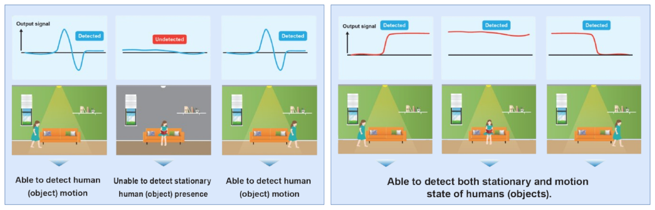

Figure 1: Visual comparison of PIR and thermal sensors for human presence detection [9]

In response to these deficiencies, alternative sensor technologies have emerged. Vision-based systems offer detailed visual information but raise privacy concerns and require adequate lighting. Radio Frequency (RF) sensors, such as millimeter-wave radiometry and Wi-Fi-based methods, have demonstrated promise in detecting human presence through non-optical means but often involve high costs and complex computational setups​ [3]. Ultrasonic and microwave sensors offer non-contact solutions but face reliability issues in certain environments.

Thermal sensing technology has recently emerged as a robust alternative, driven by advancements in Micro-Electro-Mechanical Systems (MEMS). Thermal sensors, particularly low-resolution thermal arrays like the Omron D6T series and Heimann Sensors, can detect human presence based on emitted body heat, independent of ambient lighting conditions [1]​. Importantly, thermal sensors can detect stationary individuals, addressing a critical gap left by PIR sensors.

The Omron D6T-32L-01A sensor, with its 32x32 thermal array, represents a notable advancement. It offers high spatial resolution compared to traditional thermal sensors, enabling the detection of subtle temperature variations. This granularity allows for distinguishing human presence more accurately, even in complex environments. Moreover, thermal sensors respect privacy concerns, as they capture heat signatures rather than identifiable images, making them suitable for use in sensitive spaces such as bedrooms and bathrooms [4][5].

However, the success of thermal sensors in human presence detection is not solely reliant on hardware capabilities. Robust data processing techniques are crucial to translating raw thermal data into actionable insights. Recent research highlights the role of machine learning models in enhancing detection accuracy. Traditional approaches, such as Support Vector Machines (SVM) and Multilayer Perceptron (MLP), have shown effectiveness in thermal image classification, but their performance can degrade in dynamic and cluttered environments [6]. Deep learning architectures, particularly Convolutional Neural Networks (CNNs), have demonstrated superior ability to extract spatial patterns from thermal arrays, improving detection robustness​ [7]. Hybrid models combining CNNs with temporal analysis networks like Long Short-Term Memory (LSTM) further address the challenge of recognizing human presence in scenarios involving subtle or slow movements​.

Despite these advancements, there remains a gap in developing an integrated, real-time human presence detection system that optimally balances sensor performance, computational efficiency, and deployment feasibility on embedded platforms. The need for systems capable of accurately identifying both static and moving individuals, while operating on low-power devices such as Raspberry Pi or microcontrollers, is still pressing.

This research is motivated by the growing demand for reliable, privacy-preserving human presence detection systems that seamlessly integrate into smart environments. By leveraging the high-resolution capabilities of the Omron D6T-32L-01A thermal sensor and combining it with advanced machine learning techniques, this work aims to develop a robust, real-time presence detection solution deployable on embedded hardware. The outcomes of this study are expected to contribute to the evolution of smart building systems, offering enhanced energy efficiency, improved security, and a user-centric approach to space management.

## Literature Review

### Human Presence Detection

Within the scientific fraternity, human presence detection (HPD) has been a topic of great interest, given that the applications of this domain transcend several use cases including energy management, security and surveillance systems, automation, and adaptive management in the face of climate change (Puurunen *et al.*, 2021). In particular, for surveillance and security systems within smart buildings, homes, and factories, human presence detection is crucial. (Doan *et al.*, 2024). As such, the use of device-free technology becomes imperative when an individual’s presence becomes infeasible, dangerous, or highly costly (Nanzer and Rogers, 2007). Therefore, improving the human detection accuracy of such technologies is a fundamental aspect of the system's performance. Henceforth, the option of adequate technologies for human perception has surfaced as an eminent area of contemporary research with a plethora of research focusing on the development of different sensor technologies and machine learning (ML) models as attempts to evade the shortcomings in the existing systems.

### Occupancy Detection Technologies

#### Passive Infrared (PIR) Sensors

Concerning the accumulation of occupancy data, a diverse array of sensor technologies can be employed and each of them presents its own merits and shortcomings. Among the myriad of available sensor technology types, PIR sensors have been the focus of several scholarly works due to their cost-effectiveness, non-invasive dynamics, and simple nature (Shokrollahi *et al.*, 2024). In this sense, one of the research works has been done by Andrews et al. (2020) who developed a cost-effective way to detect stationary humans within indoor spaces thereby delineating a novel method to straddle the sensor on a mobile platform. Leveraging an artificial neural network (ANN), the study showcased an augmented scope of the sensor functionalities for detecting the occupancy parameters while presenting a 91% accuracy for the count estimates of the room occupation and a 93% accuracy in distinguishing human targets. Likewise, Doan et al. (2024) put forward a machine learning (ML), in particular, learning vector quantization (LVQ) based PIR sensor technology to improve human detection accuracy. By analyzing the functioning of the intelligent sensor in distinct environments within two distinct locations, the study authors made use of generalized LVQ (GLVQ) and generalized matrix LVQ (GMLVQ) to reveal detection accuracies of 86.1% and 89.25%, respectively, thereby highlighting remarkable potential owing to the lesser computational costs of the technology (Doan *et al.*, 2024).

#### Vision-based Sensors

The technological shortcomings of PIR sensors, including the lack of detection of static humans, sensitivity to sunshine radiations and airflow, and the sub-optimal distinction between humans and animals paved a pathway for alternative technology options such as vision-based sensors. In this regard, research work by Benezeth et al. (2011) suggested a vision-based system for HPD, through a video analysis mediated by a static camera, within indoor spaces. Involving three fundamental steps of detecting a change through a background model, tracking objects, and comprehending the nature of objects in the scene, the study reported a detection accuracy of 97% with numerous applications of the technology including occupancy detection, individual counting, and activity characterization including energy-efficient buildings, HVAC, and security (Benezeth *et al.*, 2011).

#### Ultrasonic sensors

Given that they are relatively inexpensive, ultrasonic sensors can serve in unique applications of HPD where other types of sensor technologies fail to detect humans (Saleem *et al.*, 2024). This can be comprehended by the research work of van Groeningen et al. (2018) who developed an ultrasonic sensor-based system to detect HP within smoke-filled buildings and assist in HPD at times of calamities like huge fire breakouts requiring an accurate count of human occupancy. The research experimentation concerning the signal strength highlighted the capacity of ultrasonic sensors to ‘look through’ smoke, therefore suggesting the placement of indoor ultrasonic sensors for emergency circumstances. Being novel in its purpose, the study pinpointed signal detection through smoke, no need for wearable equipment, and the absence of privacy concerns benefits of the investigated sensor technology.

#### RF-based (Wifi-Based) Sensors

Radio frequency (RF) signals are yet another approach among the various human occupancy detection methods. In particular, the Wifi communication signals from the access location, Bluetooth transmissions, specifically the low energy version (BLE), and radars for frequency shifting are some of the RF-based technologies that are currently in ubiquitous utilization (Shahbazian and Trubitsyna, 2023).

Given that conventional vision-based approaches to human detection (HD) are assisted with several limitations including the absence of sensor flexibility and poor accuracy, non-intrusive methods to human presence detection have been the subject of recent research work. In particular, Mesa-Cantillo et al. (2023) present an approach to HD through the channel state information (CSI) of the Wi-Fi networks where the features within the time domain assist in HD. Through the use of the 802.11n standard, multiple-input multiple-output (MIMO) assisted with orthogonal frequency division multiplexing (OFDM) facilitates CSI data for each subcarrier, thereby allowing an average detection accuracy of 90% (Mesa-Cantillo *et al.*, 2023). Similarly, Shen et al. (2023) also employed CSI data from commercial wireless communication networks for device-free HPD through the use of a time-selective conditional dual feature extract recurrent network (TCD-FERN) within multi-room settings. Through the use of the dual-feature extraction recurrent network based on time selection serving to address the issues of feature attenuation and signal variation, the research work presents a higher detection accuracy of 97% with the use of a lesser number of Wifi access points (APs) (Shen *et al.*, 2023). In a recent attempt, Zhang et al. (2024) proposed a novel approach to HPD based on Wi-fi networks, which constituted three phases including the pre-processing of CSI followed by feature extraction and classification. The research results report a high sensing accuracy of up to 99% with accurate and robust perception and HP owing to the signal models consonant to the varying states including an empty room, a room with a human, and a room with someone who recently moved (Zhang *et al.*, 2024). Despite the promising potential, the method presents limitations concerning a distinction between the detection of a single person or multiple people, restricting the applicability of such systems (Mesa-Cantillo *et al.*, 2023).

#### Environmental Sensors

A potent approach to non-intrusive human occupancy detection is the utilization of environmental sensors that have also garnered considerable attention due to their cost-effective nature. Humidity, carbon dioxide, air pressure, and temperature sensors are the most pervasive sensors that are used alone or in combination to enhance the detection accuracy (Tsanousa *et al.*, 2023).

##### Thermal Sensors

Given the extensive amount of work being done to develop economical yet highly accurate models for HPD, a promising approach in this regard is the use of thermal sensors that especially suit non-intrusive applications. This can be understood by the scholarly work of Singh and Aksanli (2019) who developed contactless, ambient thermal sensors for HPD, as a means of detection without invading user privacy, within the smart environment. Using low-resolution sensors without any multi-media assets, the researchers highlighted the significance of algorithm selection with the sensor position, such as on the room ceiling, amplifying the algorithm performance and allowing a 100% detection accuracy. Likewise, Puurunen et al. (2021) employed an Omron D6T-44L06 thermal sensor to develop an Internet of Things (IoT) platform for HPD for automation applications that necessitate the detection of human presence to commence their functioning. The research results reported a high presence detection efficiency of 99.6% of the ANN model trained, through the Keras library, on the data collected from the Arduino Nano prototype. More recently, Chuah and Teoh (2020) presented the use case of a thermal sensor for the detection of stationary humans as a means of the intelligent control of electrical appliances within a smart home. The researchers made use of a calibration approach for adequate temperature threshold detection, and the bifurcation of the sensor area into various sections for accurate HD, allowing a reduction in electrical energy wastage and energy consumption.

The increasing development of thermal array sensors has been precipitated due to the various concerns resulting from other sensor technologies such as high costs, environmental problems, and privacy issues. As such, Lin and Zhao (2025) present a human occupancy detection system based on an 8 × 8 Infrared Thermal Array Sensor to investigate the effectiveness of the sensor in detecting human presence (HP) under varying indoor scenarios such as complete blackout and standard brightness. By leveraging adaptive thresholding, blob detection, and watershed algorithm, the researchers highlighted a reliable differentiation of thermal regions even in the presence of more people in close proximity, thereby significantly improving the HPD accuracy and dependability. Similarly, Shetty et al. (2017) investigate the human presence, specifically the static humans, by proposing the utilization of a ‘Grid-EYE’ sensor which is an infrared thermopile array sensor that allows the detection of both moving and stationary humans along with their direction of movement, thereby serving as a potent substitute in several applications including security, automation, and medical imaging, among others.

### Machine Learning Approaches for Thermal Sensor Data

#### Traditional Methods (SVM, k-NN, Decision Trees, MLP)

##### Support Vector Machines (SVM)

The need for higher HD accuracy in intelligent surveillance systems led to the use of the support vector machines (SVM) algorithm in the system design. In this sense, Fan et al. (2008) leveraged SVM as a model which employs small sample statistics approach to identify, and makes use of star and grid vectors for feature extraction of the objects. The research results reported the superior capacity of the SVM model when compared with the k-nearest neighbor and Fourier models. Likewise, another research study by Deshpande and Rana (2012) employed SVM for HPD in the surveillance videos. The study authors used features based on the 2D wavelet transform approach, where the resulting sample images served as inputs for the SVM model, signifying a detection accuracy of 100%. An interesting approach has been taken by Zubow et al. (2022) who examined the CSI information through one class SVM (OC-SVM) as a method to HD with the human presence being introduced as a novel aspect to oust the rigorous without and with human presence training. The study results syndicated a promising potential with a detection accuracy exceeding 97% while being a pragmatic and a simplistic approach.

#### Deep Learning Techniques

A glance at contemporary technological advancements allows one to deduce the increasingly escalating demands of human-machine interaction across diverse disciplines, from healthcare, transport, manufacturing, and agriculture to integrating robotic activities for accuracy with human skills. In this regard, human identification is a major concern that has been the subject of modern-day applications and has progressed through deep learning (DL) technologies. In particular, You Only Look Once (YOLO) is a modern-day algorithm that offers optimal accuracy and computational time, making it a viable option for real-world complex use cases. As such, Balachandran et al. (2020) present the development of a DL-based, specifically YOLO, HP detector to assess the algorithm's precision for human detection within a smart factory milieu. Through training on the *CrowdHuman* dataset, the YOLOv4 and YOLOv4-Tiny were benchmarked to validate the precision accuracy of the trained models and the deduction speeds on TensorFlow to reveal improved precision accuracies of 88.08% and 77.7% at 25FPS and 80FPS, respectively thereby suggesting a precision-speed compromise for the DL approaches to HPD (Balachandran *et al.*, 2020). Unlike Balachandran et al. (2020), Sivachandiran (2022) opted for a different approach by proposing a novel DL-driven automated person detection and tracking (DLD-APDT) model for identifying humans in surveillance videos. By leveraging EfficientDet as a means of detecting the object (person), followed by root mean square propagation (RMSProp) optimizer for an efficient selection of the parameters concerning the EfficientDet model as a means of improving the detection performance for the model.

***Convolutional Neural Networks (CNN)***

Latterly, the detection of humans for intelligent surveillance within complicated settings has become viable with significantly improved detection accuracy resulting from convolutional neural networks (CNNs). Apart from YOLO, CNN is yet another distinct DL-based approach to accurate HPD that has been reported to show improved detection rates, thereby replacing the conventional SVM models, specifically within edge technology. This was substantiated by Khalifa et al. (2021), who proposed a lightweight CNN (L-CNN) framework for Raspberry Pi, a limited edge equipment to highlight enhanced performance time, and detection accuracies as good as the existing SVM technologies with fast processing time. In line with Khalifa et al. (2021), Nikouei et al. (2018) also developed an L-CNN to identify the human objects, in particular, pedestrians within surveillance videos. Utilizing the Single Shot Multi-Box Detector (SSD) and depthwise separable convolutional framework, the research work highlighted a promising potential of the technology in accurate and speedy human detection.

As such, Ahmad et al. (2020) used a faster region CNN (F-RCNN) to detect humans within the overhead view video surveillance systems to showcase a high detection accuracy of 90-93% alongside a negligible false detection rate (FDR) of 0.5%. Another RCNN, specifically improved mask RCNN based, novel algorithm has been proposed by Wang et al. (2020) for HPD within complex scenarios where the researchers integrated FPN and ResNet to augment the detection capacity of the mask RCNN framework. The research results highlighted an enhanced detection accuracy through effective elimination of error fusion target and redundant data with an assisted improvement of local traits.

Within the computer vision domain, the concept of intelligent surveillance systems is of utmost significance. Of particular value is the systematic analysis of systems that function well during nighttime when no natural light exists. As such, Park et al. (2020) undertook a CNN-based approach for the infrared CCTV cameras for HPD at night hours to avoid intrusion into the dangerous zones as a means of preventing mishaps. Making use of two infrared image datasets from the beach and one from a pedestrian bridge, the study results delineated a superior performance of the CNN-based fine grained human detection approach than the conventional methods of HD with F1 scores exceeding 90% for object level detection for each of the datasets and an optimal computational speed (Park *et al.*, 2020). However, infrared cameras are limited by the specific angle and distance, along with the power adjustment needs based on the proximity of the object. Thereupon, Kim et al. (2017) employed CNN approach for human detection at night but through the capture of a single image by the visible light camera within different environments.

While there has been a greater focus on external (outdoor) human detection, it is evident that human detection within indoor environments has been a less frequent subject of research. Even those that have researched HD within indoor spaces have emphasized facial recognition, given the proximity of the individuals in the indoor settings. However, the detection accuracy of the facial recognition is highly compromised in indoor spaces. Therefore, Koo et al. (2018) have developed a multimodal HD approach, based on CNN, that leverages the facial and body features to recognize the humans, thereby depicting higher detection accuracy than approaches that leverage either face or body single mode recognition approach.

***Hybrid Models***

While several machine learning models have been utilized as classifiers to predict the HP, a novel approach to human identification is the use of hybrid classification models for enhanced prediction accuracy and synergizing the strengths of each classifier. As such, Ahmad Mahmud and Azuana Ramli (2020) introduced a hybrid classifier approach to human occupancy detection within smart buildings as a means to compare the performance of the model with individual classifiers including k nearest neighbor and decision tree. Similarly, another research work by Akshatha et al. (2022) evaluated the performance of two machine learning models, particularly single shot multi box detector (SSD) and FR-CNN, with differing backbone networks including ResNet50, MobileNet-v1, and Inception-v2 to identify the human objects within the aerial images captured from thermal sensors. The study results signified a superior detection accuracy of the FR-CNN machine learning model concatenated with the ResNet50 backbone network, with a mean average precision accuracy (mAP) of 100% for the thermal dataset while the greatest detection speed of 44 frames per second (FPS) resulted from SSD with MobileNet-v1 framework.

### Summary of Key Papers

### Identified Gaps

## Problem Statement and Objectives

PIR sensors have long been used for presence detection in smart environments due to their low cost and simplicity. However, they fail to detect stationary individuals and often trigger false positives from environmental noise. Thermal sensors like the Omron D6T-32L-01A offer a compelling solution by detecting heat signatures continuously, even when a person is not moving. But raw thermal data alone isn't useful, it requires intelligent processing.

The problem lies in building a presence detection system that can take this thermal input and make accurate real-time decisions, even in challenging scenarios like static presence or background heat interference. More importantly, such a system should run on a practical, low-cost platform that can actually be deployed, not just simulated in ideal conditions.

This thesis focuses on solving that problem by designing and training a machine learning model that works with thermal data, implements background adaptation, and runs in real time on a Raspberry Pi. The goal is to move beyond theoretical performance and prove that accurate, reliable presence detection is possible on embedded systems without compromising speed, efficiency, or usability.

### Objectives

This thesis aims to develop a robust, real-time human presence detection system using thermal sensor data, with deployment on embedded hardware platforms. The specific objectives are:

1. To collect and preprocess thermal sensor data using the Omron D6T-32L-01A MEMS thermal array, capturing various human presence conditions, including motion, static presence, and no-presence scenarios.
2. To design and train machine learning models; including 1D CNN, and Temporal CNN for binary classification of human presence, and evaluate their performance using metrics such as accuracy, precision, and robustness under dynamic conditions. Compare these models against a baseline MLP to assess performance improvements.
3. To implement adaptive background removal techniques that suppress static heat sources and allow the system to adapt to environmental changes in real time.
4. To deploy the optimized model on a Raspberry Pi, achieving real-time inference performance while maintaining accuracy and reliability under embedded constraints.
5. To evaluate and compare system performance against traditional PIR-based sensors, focusing on false positives, detection latency, and ability to detect stationary individuals.
6. (Extended Objective) To explore the feasibility of ESP32-S3 deployment, including model quantization, memory optimization, and performance validation on ultra-low-power microcontroller hardware.

# Methodology

## Description of the Hardware

The human presence detection system is built using a combination of advanced thermal sensing and embedded computing. The key hardware components include:

* **Thermal Sensor**: Omron **D6T-32L-01A** MEMS thermal sensor, chosen for its high-resolution thermal detection capability.
* **Microcontroller/Embedded System**: **Raspberry Pi 4**, selected for its powerful processing capability and compatibility with advanced machine learning frameworks.
* **Power Supply**: A stable 5V DC supply to power the sensor and microcontroller.
* **Communication Interface**: I2C protocol for data transfer between the sensor and Raspberry Pi.

These components together enable real-time, high-accuracy human presence detection suitable for smart environments and industrial applications. Figure 2 provides a visual overview of the key hardware modules used in the system, including the Omron D6T-32L-01A thermal sensor, Raspberry Pi 4, interface board, and connection harness.

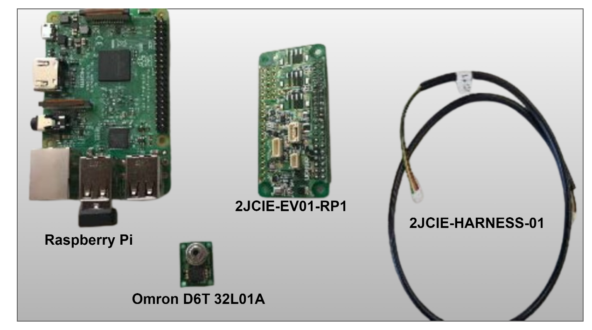

Figure 2: Key Hardware Components

### Why Thermal Sensing?

Human presence detection is a crucial component in various applications, including smart buildings, security surveillance, and energy-efficient automation. Several sensing modalities exist for detecting human presence, including **LiDAR, RADAR, RGB cameras, HADAR, and PIR sensors**. However, each of these technologies has inherent limitations that make them less suitable for reliable and privacy-preserving human detection in indoor environments. Thermal sensing was selected as the preferred approach in this study due to its unique advantages over these alternative technologies.

**Comparison of Sensing Modalities**

1. **LIDAR (Light Detection and Ranging):** LiDAR is a high-precision sensing method commonly used in autonomous vehicles and industrial automation. It operates by emitting laser pulses and measuring their reflections to create 3D spatial maps. However, LiDAR is relatively expensive, power-intensive, and overly complex for simple human presence detection applications in indoor settings. Additionally, it may struggle with occlusions and detecting stationary individuals.
2. **RADAR (Radio Detection and Ranging):** RADAR systems use radio waves to detect motion and objects. While effective in detecting movement, RADAR lacks fine spatial resolution required to distinguish humans from other objects in cluttered indoor environments. It also suffers from multipath interference, making reliable human presence detection challenging.
3. **RGB Cameras:** Vision-based sensors, such as conventional cameras, offer high-resolution data for detecting and tracking humans. However, their effectiveness depends on ambient lighting conditions. Additionally, RGB cameras raise privacy concerns, especially in indoor spaces such as homes and offices, as they capture identifiable images of individuals.
4. **HADAR (Hybrid Active-Passive Detection and Ranging):** A relatively new technology, HADAR integrates active and passive sensing to enhance human perception in various conditions. While HADAR shows promise, it is still in early-stage research and development, making it impractical for real-world deployment at this time.
5. **PIR (Passive Infrared) Sensors:** PIR sensors detect motion based on changes in infrared radiation. While cost-effective and widely used, PIR sensors cannot detect stationary humans and are prone to false positives in dynamic environments with temperature fluctuations.

**Advantages of Thermal Sensing**

Compared to the alternatives, thermal sensing provides the following benefits:

* **Works in total darkness:** Unlike RGB cameras, thermal sensors operate independently of lighting conditions, making them effective in low-light or night-time applications.
* **Detects human presence even when stationary:** Unlike PIR sensors, which rely on motion, thermal imaging can recognize the presence of a stationary person based on their heat signature.
* **Privacy-friendly:** Unlike vision-based systems, thermal sensors do not capture identifiable facial details, addressing privacy concerns associated with RGB cameras.
* **Robust to lighting and environmental variations:** Unlike LIDAR and RADAR, thermal sensors are not significantly affected by reflections, shadows, or background noise, making them more reliable in complex indoor environments.
* **Low power consumption and simple integration:** Compared to LIDAR and RGB cameras, thermal sensors consume less power and are easier to integrate with embedded systems.

Based on these advantages, thermal sensing was chosen as the primary technology for human presence detection in this study. The next section discusses different types of thermal sensors and their underlying principles.

### Introduction to Thermal Sensing

Thermal sensors detect infrared radiation (IR) emitted by objects to measure temperature variations without physical contact. These sensors are classified into three main types based on their detection mechanism: **bolometers, thermopiles, and pyroelectric sensors**.

* **Bolometers**: These sensors consist of a material whose electrical resistance changes with temperature. When infrared radiation is absorbed, the material's temperature increases, causing a measurable resistance change. Bolometers are widely used in high-precision thermal imaging applications, including astronomy and infrared spectroscopy. Figure 3 shows an overview of working of Bolometer based thermal sensor.

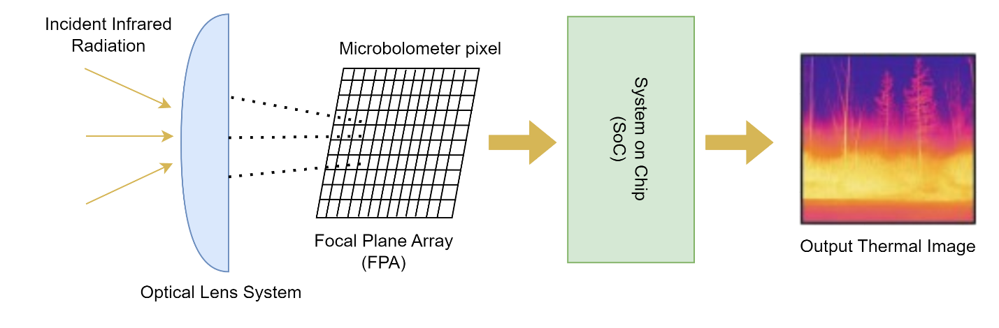

Figure 3: Working of Bolometer Based Thermal Sensor

* **Thermopiles**: These sensors are composed of multiple thermocouples connected in series to detect minute temperature differences. They generate a voltage proportional to the thermal radiation received, making them highly sensitive for human presence detection and environmental monitoring. This process is based on the **Seebeck effect**, where a thermoelectric voltage is generated due to the temperature difference across the junctions of two dissimilar metals. **Figure 4** below illustrates the working principle of a thermopile sensor.
* **Pyroelectric Sensors**: Pyroelectric materials generate an electric charge when exposed to temperature fluctuations. Unlike thermopiles, which measure continuous radiation, pyroelectric sensors detect only changes in infrared intensity, making them ideal for motion detection applications, such as Passive Infrared (PIR) sensors used in security systems.

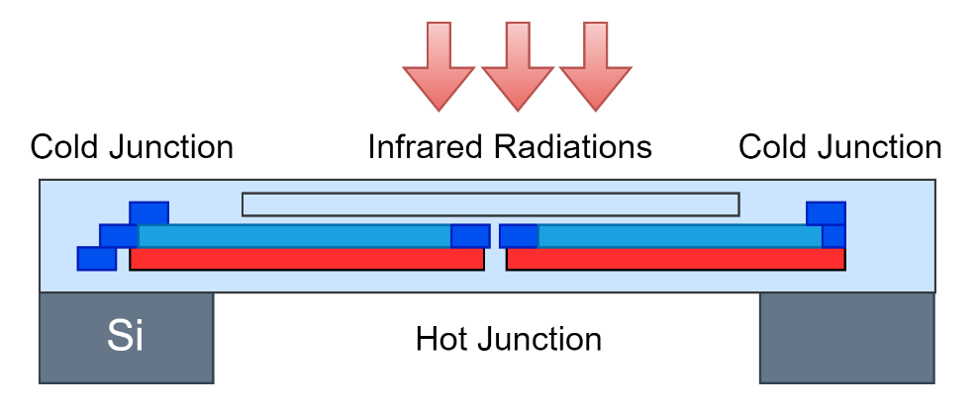

Figure 4: Thermopile sensor detection principle

### Sensor Working Principle and Performance

The Omron D6T-32L-01A is a MEMS-based infrared thermal sensor designed for contactless temperature measurement. It operates on the principle of thermopile technology, where multiple thermopile elements detect far-infrared radiation (8–14 µm wavelength) emitted from objects in its field of view.

**Working Principle:**

The Omron D6T-32L-01A sensor functions by detecting infrared radiation from objects and converting it into temperature readings as shown in Figure 3 below. The sensor is equipped with a silicon lens that focuses the far-infrared radiation onto an array of 1024 thermopile elements arranged in a 32×32 grid. Each thermopile element absorbs the radiation and generates an electromotive force proportional to the detected temperature.

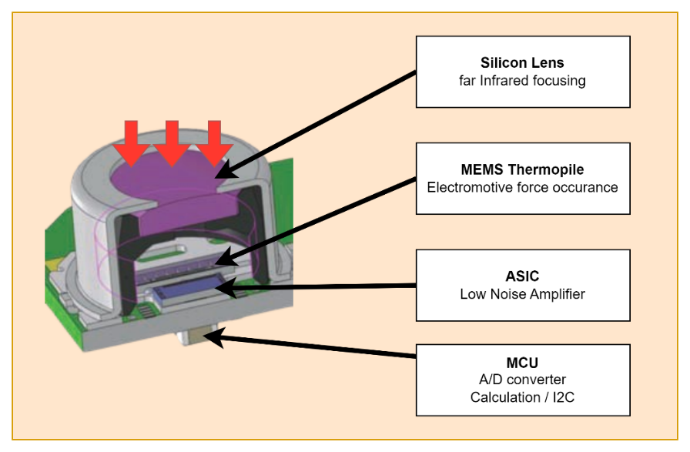

Figure 5: MEMS Thermopile Sensor

The raw signals from these thermopile elements are then processed by an Application-Specific Integrated Circuit (ASIC), which converts the voltage values into temperature data. To enhance accuracy and stability, the sensor integrates an internal reference temperature sensor that helps in background compensation, adjusting for environmental variations that might otherwise affect the readings. This ensures consistent and precise temperature measurements across varying ambient conditions.

The digital temperature data is then output via the I2C interface, making it easily integrable with embedded systems like the Raspberry Pi 4. This entire process allows the Omron D6T-32L-01A to detect both moving and stationary human presence with high reliability, making it particularly suitable for smart environments, security applications, and energy management systems.

The Omron D6T-32L-01A is particularly advantageous in scenarios requiring the detection of stationary human presence, where PIR sensors typically fail. Unlike PIR sensors, which only detect motion, the Omron D6T continuously monitors thermal patterns, making it an ideal solution for smart building automation, security applications, and occupancy-based energy management systems.

### Comparative Analysis of Thermal Sensors for Human Presence Detection

The selection of an appropriate thermal sensor for human presence detection requires a comprehensive evaluation of key factors, including resolution, field of view (FOV), thermal sensitivity, frame rate, power consumption, interface compatibility, and cost. In this study, four thermal sensors: Omron D6T-32L-01A, Heimann 32×32, MLX90640, and FLIR Lepton 3.5 were compared to determine their suitability for occupancy detection applications as shown below in Table 1.

Among these, resolution and field of view (FOV) play a crucial role in capturing fine-grained thermal details and ensuring adequate spatial coverage. The Omron D6T-32L-01A and Heimann 32×32 both feature a 32×32 (1024 pixels) resolution, providing sufficient spatial granularity for human presence detection. The MLX90640 (32×24, 768 pixels) offers slightly lower resolution, while the FLIR Lepton 3.5 (160×120, 19,200 pixels) boasts the highest resolution among the selected sensors. However, FLIR's high-resolution imaging is more suited for medical diagnostics and surveillance applications, where detailed thermal imaging is required, rather than for human presence detection, which primarily relies on heat signature differentiation.

The field of view (FOV) determines the sensor's coverage area, impacting its efficiency in room-scale monitoring. The Heimann 32×32 provides the widest FOV (110° × 110°), followed by the Omron D6T-32L-01A (90° × 90°), making them ideal for monitoring larger spaces. The MLX90640 offers multiple FOV configurations (55° × 35° or 110° × 70°), allowing for application-specific adjustments, whereas the FLIR Lepton 3.5 (57° × 42°) has a narrower FOV, which may be restrictive for some presence detection scenarios.

Table 1: Technical Comparison of Thermal Imaging Sensors

|  |  |  |  |  |
| --- | --- | --- | --- | --- |
| **Features** | **Omron D6T 32L 01A** | **Heimann 32×32** | **MLX90640** | **FLIR Lepton 3.5** |
| Resolution | 32 × 32 (1024 pixels) | 32 × 32 (1024 pixels) | 32 × 24 (768 pixels) | 160 × 120 (19,200 pixels) |
| Field of View (FOV) | 90° × 90° | 110° × 110° | 55° × 35° / 110° × 70° | 57° × 42° |
| Temperature Range | 0°C to 200°C | -20°C to 100°C | -40°C to 300°C | -10°C to 400°C |
| Thermal Sensitivity (NETD) | 0.33°C | 0.07°C | 0.1°C | ≤ 0.05°C (50mK) |
| Frame Rate | 10 Hz (fixed) | 7 Hz | 0.5 to 64 Hz | 8.6 Hz |
| Power Consumption | 95mW (5V, 19mA) | 18.15mW (3.3V, 5.5mA) | 79mW (3.3V, 27mA) | 150mW (3.3V, ~45mA) |
| Interface | I2C | I2C, SPI, UART | I2C | SPI (MIPI, VoSPI) |
| Best Use Case | Optimized for human presence detection | High-resolution thermal imaging | Fast industrial thermal scanning | High-precision thermal imaging for surveillance and medical use |
| Working Distance | Up to 3m | Minimum 24mm | 2m/1m | NA |
| Cost (DKK) | Medium | Moderate Low | Low | High |

Thermal sensitivity, quantified as Noise Equivalent Temperature Difference (NETD), is a key factor in detecting subtle temperature changes. The FLIR Lepton 3.5 (≤ 0.05°C) provides the highest sensitivity, followed by Heimann 32×32 (0.07°C) and MLX90640 (0.1°C), making them ideal for applications requiring fine temperature differentials. The Omron D6T-32L-01A, with a NETD of 0.33°C, is comparatively less sensitive. However, for human presence detection, extreme sensitivity is not always necessary, as human thermal signatures typically exhibit significant temperature variations from background objects, making moderate sensitivity sufficient for accurate detection.

Frame rate and power consumption are critical considerations for real-time applications. The MLX90640 offers a configurable frame rate (0.5 to 64 Hz), making it highly adaptable for dynamic thermal scanning applications. However, for stable human presence detection, fixed frame rates are often preferred. The FLIR Lepton 3.5 (8.6 Hz), Heimann 32×32 (7 Hz), and Omron D6T-32L-01A (10 Hz fixed) provide consistent and stable frame rates, making them more suitable for occupancy detection. In terms of power efficiency, Heimann 32×32 consumes the least power (18.15mW, 3.3V, 5.5mA), making it an excellent option for battery-powered applications. The MLX90640 (79mW, 3.3V, 27mA) and Omron D6T-32L-01A (95mW, 5V, 19mA) balance power efficiency and performance, ensuring feasibility for embedded applications. However, FLIR Lepton 3.5 has the highest power consumption (150mW, ~45mA), making it less suitable for energy-constrained environments.

Another crucial factor in sensor selection is interface compatibility, which determines ease of integration with embedded systems. The Omron D6T-32L-01A and MLX90640 use the I2C protocol, ensuring straightforward connectivity with microcontrollers like the Raspberry Pi. The Heimann 32×32 supports multiple interfaces (I2C, SPI, UART), offering greater flexibility, while the FLIR Lepton 3.5 requires SPI (MIPI, VoSPI), which can introduce additional complexity in interfacing with standard microcontrollers. Furthermore, Cost also plays a significant role in selection, as affordability influences large-scale deployment feasibility. The MLX90640 is the most cost-effective option, followed by Heimann 32×32, Omron D6T-32L-01A, and FLIR Lepton 3.5, which is the most expensive sensor. While cost is a factor, it must be weighed against overall performance and ease of integration for specific applications.

Based on this comparative analysis, the Omron D6T-32L-01A was selected as the most suitable sensor for this study due to its balance of resolution, frame rate stability, power efficiency, and ease of integration with Raspberry Pi. While its NETD is not the lowest, its dedicated design for human presence detection, stable fixed frame rate, and low power consumption make it highly practical for applications in smart buildings, security systems, and occupancy-based automation.

The Heimann 32×32 sensor presented a strong alternative, with comparable resolution, high sensitivity, and an expansive field of view, making it a promising candidate for human presence detection. However, procurement challenges and limited market availability hindered its immediate implementation. If availability improves, Heimann 32×32 could serve as a viable alternative in future studies. Similarly, the MLX90640 and FLIR Lepton 3.5 exhibit advanced capabilities suited for thermal scanning and surveillance applications. However, their design characteristics make them better suited for industrial, medical, or security-related use rather than human occupancy detection.

In summary, the Omron D6T-32L-01A was chosen for its optimal trade-off between resolution, efficiency, stability, and ease of deployment in real-world environments. While other sensors offered advantages in specific aspects, they either introduced complexities in integration, had excessive power consumption, or were not readily available for procurement. Thus, the Omron D6T-32L-01A remains the most practical choice for human presence detection, ensuring a reliable, scalable, and efficient solution.

### Selection of Microcontroller

The primary objective of this thesis was to develop a machine learning algorithm capable of detecting human presence under various environmental and operational conditions. While embedded microcontrollers (MCUs) are commonly used for low-power applications, the focus of this research was not on deploying the model on a resource-constrained embedded system but rather on ensuring ease of implementation, real-time inference, and compatibility with machine learning frameworks. Given these requirements, the **Raspberry Pi 4** was chosen as the processing unit due to its computational efficiency, ease of deployment, and extensive support for edge AI applications.

The Raspberry Pi 4 is powered by a quad-core Cortex-A72 processor (1.5GHz), enabling real-time processing of high-resolution thermal data from the Omron D6T-32L-01A sensor. Its support for multiple RAM configurations (2GB, 4GB, 8GB) allows for efficient data buffering and preprocessing, making it highly suitable for running machine learning inference. Additionally, its built-in I2C interface facilitates seamless communication with the thermal sensor, while USB, Wi-Fi, and Ethernet capabilities enable remote monitoring, data logging, and cloud integration.

Furthermore, the Raspberry Pi 4 supports TensorFlow Lite and OpenCV, making it an ideal choice for edge AI applications where real-time inference and efficient computation are essential. By leveraging the expandability and processing power of the Raspberry Pi 4, this system ensures fast, efficient, and scalable thermal image processing, suitable for applications in smart environments, security surveillance, and energy-efficient automation systems. The decision to use the Raspberry Pi 4 aligns with the broader objective of this research—to develop a practical and deployable solution for real-world implementation without the constraints of low-power embedded MCUs.

## Data Collection

### Mounting Angles and Considerations

The placement and orientation of the Omron D6T-32L-01A sensor play a crucial role in optimizing coverage and detection accuracy. Two primary mounting configurations were tested: ceiling mounting and wall mounting at different heights. Each setup presents unique advantages and limitations that influence detection efficiency, field of view, and overall performance.

**Ceiling Mounting**

In the ceiling-mounted configuration, the sensor was installed at a height of 2.4 meters, positioned directly above the monitoring area as showing in the Figure 4 and 5 below. This setup provided direct downward coverage, making it particularly suitable for applications that require precise detection of human presence within a specific zone. Since the sensor had an unobstructed top-down perspective, false positives were minimized, and detection remained consistent as no furniture or objects interfered with the field of view. However, this mounting position also introduced certain limitations. Due to its restricted field of view (FoV), the sensor was unable to effectively detect human presence near the edges of larger rooms. Additionally, the ground coverage was limited to 2m × 2m, making it less suitable for applications requiring broader detection areas. Another challenge was the limited ability to track movement direction, as the sensor primarily detected heat signatures directly beneath it rather than capturing lateral movement. This restriction made the ceiling-mounted setup more effective for stationary human detection rather than tracking movement across a room.

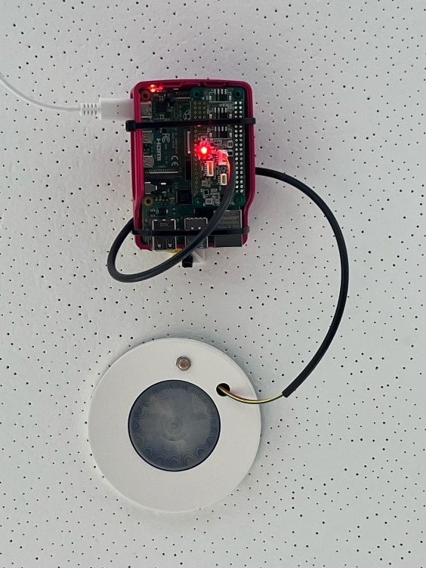

Figure 6: Ceiling Mount - Room View Figure 7: Ceiling Mount - Close-up View

**Wall Mounting**

To address the limitations of ceiling mounting, an alternative wall-mounted configuration was explored by installing the sensor at a height of 2.1 meters, positioned at the corner of the room as shown in Figure 6. This placement significantly improved the field of view, allowing the sensor to cover an area of approximately 3m × 3m, which was nearly 50% greater than the ceiling-mounted setup. The angled placement of the sensor allowed for more comprehensive room monitoring, enhancing its ability to detect both stationary and moving occupants. Unlike the ceiling-mounted position, the wall-mounted sensor could track movement direction more effectively, capturing lateral motion as individuals moved across the room. Additionally, thermal mapping was enhanced, as the sensor had a more natural, side-view perspective of the environment, resulting in more detailed heat distribution analysis. However, wall mounting also introduced certain drawbacks. Potential obstructions from furniture or objects could create blind spots, reducing detection efficiency. The positioning of the sensor also required careful alignment, as incorrect angling could affect detection accuracy. Furthermore, occupants positioned too close to walls or corners could be less detectable compared to those located in the center of the room.

**Comparison and Conclusion**

Both mounting configurations present distinct trade-offs. Ceiling mounting at 2.4 meters is optimal for detecting stationary human presence in a fixed area, particularly in settings where false positives need to be minimized. However, wall mounting at 2.1 meters provides broader room coverage and is more effective in tracking movement, making it the preferable choice for scenarios that require comprehensive room monitoring. Based on these observations, the wall-mounted approach was determined to be the most effective configuration for maximizing detection accuracy while ensuring minimal blind spots.



Figure 8: Wall Mount - Room View

### Controlled Environment Considerations and Standards decided

To ensure high-quality data collection for model training, all experiments were conducted in a carefully controlled environment. The data collection process was structured into different scenarios, progressively increasing in complexity to ensure robustness and generalizability of the dataset. The first step involved collecting thermal data in an empty room, establishing a baseline for ambient temperature variations and sensor noise levels. This baseline was crucial in understanding the natural fluctuations in the environment and providing a reference point for subsequent human presence detection experiments.

Following the baseline recording, data was collected in a second scenario where a human subject was present in the room. This helped assess the ability to differentiate between occupied and unoccupied spaces, ensuring that the dataset captured meaningful variations in thermal signatures due to human presence. This simplistic approach laid the foundation for further complexity in data collection, allowing for an incremental increase in environmental variables to observe their effects on sensor readings.

To simulate real-world conditions more accurately, the study was extended by introducing electrical appliances into the environment. Devices such as mobile phones, laptops, filament lamps, and a television were included to assess their impact on thermal readings as shown in Figure 7 below. These appliances generate varying levels of infrared radiation, and their presence in the dataset was essential to ensure that the model could distinguish between human heat signatures and non-human heat sources. The appliances were introduced in different configurations, starting with a single laptop and two mobile phones, then incrementally adding filament lamps, multiple laptops, and a television. This step ensured that the dataset included diverse conditions where the sensor encountered multiple heat-emitting objects, simulating office or home environments where human presence must be detected despite surrounding thermal noise.

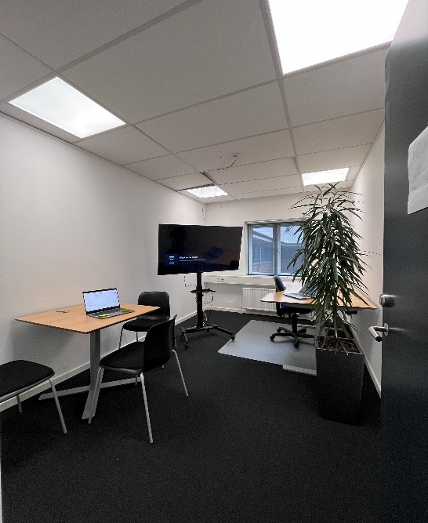

Figure 9: Room View

Expanding the study further, radiators were introduced into the experimental setup. Unlike electronic appliances, which produce localized heat spots, radiators create widespread thermal variations across the room, more closely mimicking human body heat distribution. This added a critical layer of complexity, as the sensor needed to correctly differentiate between background heating from radiators and actual human presence. The radiator experiments included varying heating intensities and placement configurations, ensuring that the dataset covered a range of environmental conditions where centralized heating systems were in operation.

Finally, the data collection process incorporated different human postures and movement patterns to further enrich the dataset. The human was present at varying distances from the sensor (ranging from 1m to 3m) and tested in multiple postures, including standing, sitting, and walking. These variations ensured that the collected data represented real-world scenarios, where individuals may be engaged in different activities while occupying a room. The inclusion of movement patterns was essential to ensure that the final model could differentiate between static and dynamic human presence, enhancing its applicability in practical deployment scenarios.

In conclusion, the controlled environment and structured data collection process ensured that the dataset was highly diverse, representative, and reliable for model training. The incremental introduction of appliances, radiators, and movement variations allowed for the generation of a robust dataset that accurately captures the complexities of human presence detection in real-world settings. This methodological approach guarantees that the resulting machine learning model can generalize well across different environmental conditions, making it suitable for applications in smart buildings, occupancy-based energy management, and security systems.

## Preprocessing and Data Augmentation

### Hand Crafted Feature Extraction

To enhance the model’s ability to distinguish between human presence and background noise, a set of handcrafted feature extraction techniques was applied to the thermal data. These features capture key structural and statistical properties that extend beyond raw pixel intensities, improving the model’s discriminative power when classifying human and non-human thermal patterns. The extracted features include:

* **Gradient-Based Features:**

Local temperature gradients were calculated in both the horizontal and vertical directions. These features highlight spatial transitions in intensity that often occur around object boundaries. As shown in *Figure 8*, gradients ∂T/∂x and ∂T/∂y reveal edge-like patterns corresponding to human presence contours.

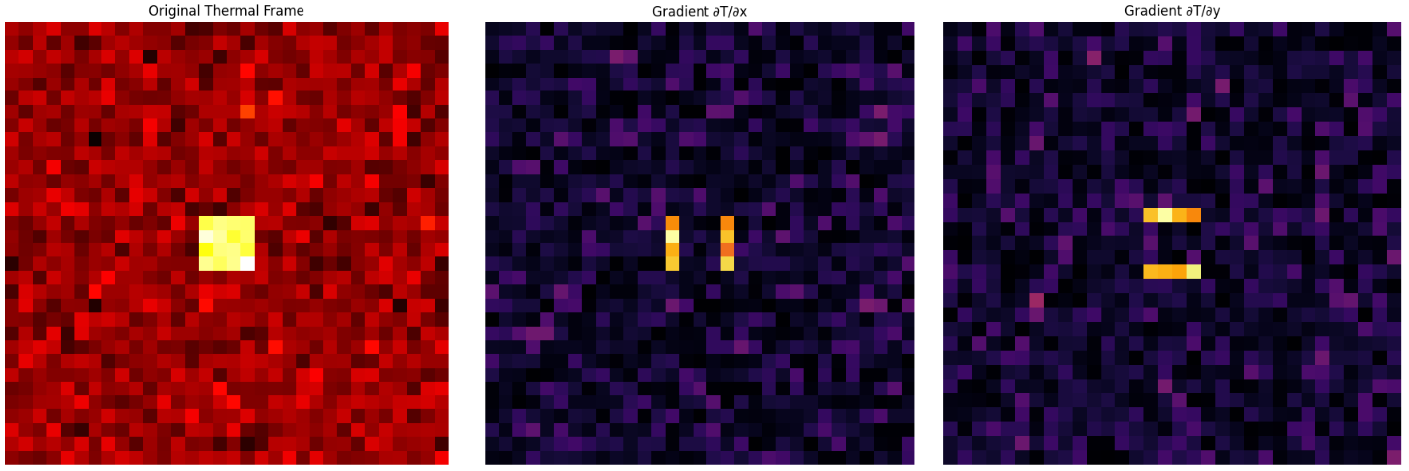

Figure 10: Gradient Based Feature Extraction

* **Hot Region Variance:**

The region surrounding the maximum temperature pixel was isolated, and its variance was computed to quantify the spread of heat. This allows the model to distinguish between compact, localized sources of heat (e.g., humans) and broader, diffuse sources (e.g., radiators). This step is illustrated in *Figure 9*, where the square highlights the region of interest.

* **Edge-based Features:**

Using the Sobel operator, a gradient magnitude map was generated to capture overall edge strength in the frame. The resulting edge magnitude (as seen in *Figure 9*) emphasizes structural intensity changes, which serve as strong indicators of human form and motion.

These extracted features were standardized using a feature scaler, ensuring that all inputs were normalized for optimal model training. By integrating these additional features alongside raw thermal data, the classification accuracy of human presence detection was significantly improved.

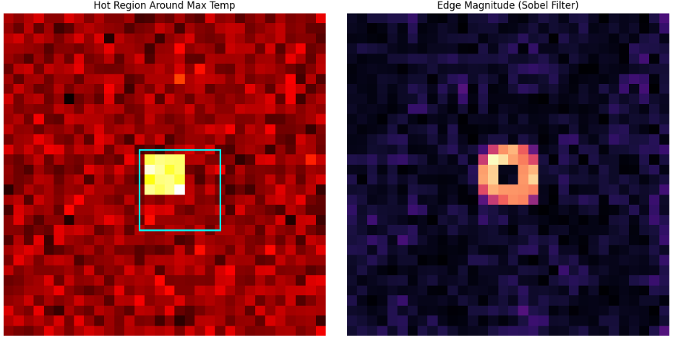

Figure 11: Hot Region and Edge Detection

### Data Augmentation Techniques

To improve the generalization capability of the model and prevent overfitting, various **data augmentation techniques** were applied. Unlike traditional RGB-based image processing, thermal images possess unique characteristics, necessitating specialized augmentation methods. The key techniques used were:

* **Random Flipping & Rotation:** Since the orientation of a human subject may vary in real-world applications, random flipping and rotation were applied to simulate different perspectives.
* **Scaling & Normalization:** Pixel intensity values were normalized to ensure uniformity across different thermal conditions.

These augmentation strategies ensured that the model learned **invariant representations** of human presence, making it more robust against variations in subject positioning and environmental conditions.

### Background Removal for Static Heat Suppression

One of the critical challenges in human presence detection using thermal imaging is the presence of static heat sources, such as radiators, televisions, and other electronic devices. These heat sources can introduce noise into the model, leading to false positives. To mitigate this, a background subtraction approach was implemented.

**Implementation of background removal (Exponential Moving Average)**

To model the background effectively, an exponential moving average (EMA) approach was used. Given a sequence of thermal frames with no human presence, the background model $B_{t}$ was computed as:

$$B_{t}= αF_{t}+(1-α)B_{t-1}$$

Where $α$ is the update rate (typically set to 0.05). This approach ensures that the background model adapts gradually to slow environmental changes without capturing dynamic elements such as human movement.

**Background subtraction**

Once the background model was computed, it was subtracted from each incoming frame $F_{t}$ to isolate dynamic heat signatures:

$${F^{'}}_{t}= max⁡(F_{t}-B_{t},0)$$

Where ${F^{'}}_{t}$ represents the Foreground features, ensuring that only human-induced thermal variations are retained while static heat sources are removed.

**Justification and Advantages**

The effectiveness of adaptive background subtraction in human detection has been demonstrated in multiple studies. It enhances model robustness by ensuring that static thermal sources do not interfere with human detection. Key advantages of this approach include:

* **Reduced False Positive:** By removing static heat sources, the model focuses solely on human-induced thermal changes.
* **Improved Detection Accuracy:** Ensures that only dynamic heat signatures contribute to classification decisions.
* **Enhanced Generalization:** Allows the model to adapt to different room environments with varying thermal conditions.

By integrating handcrafted feature extraction, augmentation techniques, and background removal the training dataset was optimized for real-world scenarios, ensuring reliable human presence detection across different environments.

#### Real-Time Background Adaptation

Although a precomputed background model was initially used, a real-time background adaptation mechanism was introduced to enhance model robustness in varying thermal conditions. During live inference, the background model is continuously updated only when the model predicts no human presence, ensuring that transient heat sources (such as a recently present human) do not get incorporated into the background model. The update mechanism is defined as:

$B_{t}= αF_{t}+\left(1-α\right)B_{t-1} if P(Human)<τ$

where P(Human) is the predicted probability of human presence, and τ is a threshold (typically 0.5). This allows the background to dynamically adapt without erroneously incorporating human-induced heat signatures. A visual representation of this conditional background update mechanism is shown in Figure 8.

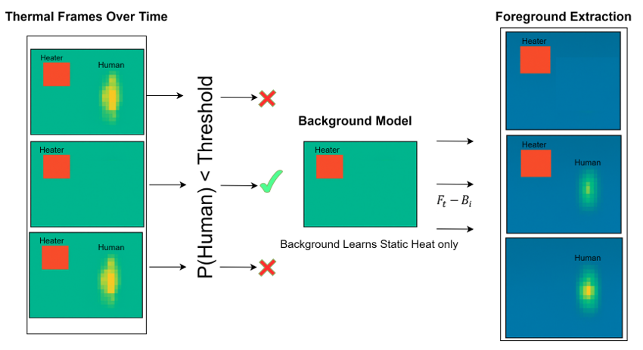

Figure 12: Exponential Moving Average for Conditional Background Adaptation

#### Comparison with other Background Subtraction Methods

A variety of background subtraction methods exist, each offering different trade-offs between adaptability, computational cost, and accuracy. In this study, the Exponential Moving Average (EMA) approach was chosen due to its computational efficiency, making it well-suited for real-time deployment on Raspberry Pi.

The Table 2 below summarizes the key differences:

Given the constraints of embedded deployment on Raspberry Pi, the EMA-based approach was selected for its balance between computational efficiency and accuracy.

Table 2: Comparison of Background Subtraction Methods

|  |  |  |  |  |
| --- | --- | --- | --- | --- |
| **Methods** | **Mathematical Approach** | **Working Principle** | **Advantages** | **Limitations** |
| Exponential Moving Average (EMA) |  | |  | | --- | |  |  |  | | --- | | Updates the background gradually using an exponential moving average, adapting only in no-human frames. | | Fast, lightweight, real-time adaptation | Can be slow for abrupt background shifts |
| Gaussian Mixture Model (GMM) | $${P(X}_{t})= ∑w_{i},tN\left(X_{i};u_{i},t,∑i,t\right)$$ | Models each pixel as a **mixture of Gaussian distributions**, allowing it to distinguish between multiple background states. | Handles multimodal backgrounds (e.g., flickering heat sources) | Computationally expensive, requires tuning |
| KNN-based Background Subtraction | $$B_{t}=\frac{1}{K} {∑_{i-1}}^{K}F_{t-1}$$ | Compares the current pixel with its past KKK frames to determine if it's part of the background. | Robust to dynamic heat sources | Requires significant memory, not efficient for edge deployment |

## Machine Learning Models

In this study, four different machine learning models were explored for human presence detection using thermal imaging data: 1D CNN, 2D CNN with feature extraction, CNN + LSTM, and Temporal CNN. Each model was evaluated based on its ability to capture spatial and temporal patterns, as well as its feasibility for real-time deployment on Raspberry Pi.

### 1D CNN Model

The first approach was a 1D Convolutional Neural Network (1D-CNN). This model was selected as a baseline due to its efficiency in processing sequential sensor data. Unlike 2D CNNs, which extract spatial features from images, a 1D CNN processes temperature variations over a single dimension, making it suitable for understanding linear patterns within thermal sensor readings.

The Omron D6T-32L-01A sensor outputs a 32×32 thermal grid (1024 temperature values), which is flattened into a 1D vector before being fed into the model. The model architecture consists of three 1D convolutional layers, each followed by Max Pooling to progressively extract hierarchical features. Fully connected layers are then used for final classification. The Table 3 shows the full architecture of 1D CNN model.

Table 3: 1D CNN Model Architecture

|  |  |  |
| --- | --- | --- |
| **Layer** | **Type** | **Output Shape** |
| Conv1 | 1D Convolution | (Batch, 16, 1024) |
| MaxPool1 | Max Pooling (2) | (Batch, 16, 512) |
| Conv2 | 1D Convolution | (Batch, 32, 512) |
| MaxPool2 | Max Pooling (2) | (Batch, 32, 256) |
| Conv3 | 1D Convolution | (Batch, 64, 256) |
| MaxPool3 | Max Pooling (2) | (Batch, 64, 128) |
| Flatten | Fully Connected | (Batch, 64×128) |
| Dense1 | Fully Connected | (Batch, 128) |
| Output | Softmax | (Batch, 2) |

While 1D CNN demonstrated reasonable performance, it suffered from inability to capture both spatial and temporal patterns. The model was unable to differentiate complex movement variations over time, leading to limited accuracy. This limitation led to the development of 2D CNNs.

### 2D CNN Model with Feature Engineering

To enhance spatial feature extraction, a 2D Convolutional Neural Network (2D-CNN) combined with handcrafted feature engineering was introduced. Unlike 1D CNNs that treat data as a sequence, 2D CNNs leverage spatial correlations in thermal images, improving the model’s ability to detect human presence more effectively. In addition to raw thermal images, handcrafted features were extracted to improve classification performance. These features included:

* **Local gradient variations**, capturing temperature differences in localized areas.
* **Hot region variance**, measuring heat distribution across different sections of the frame.
* **Radial hotspot distance**, determining how far the hottest region is from the center of the image.

Table 4: 2D CNN Model Architecture

|  |  |  |
| --- | --- | --- |
| **Layer** | **Type** | **Output Shape** |
| Conv1 | 2D Convolution | (Batch, 16, 32, 32) |
| MaxPool1 | Max Pooling (2) | (Batch, 16, 16, 16) |
| Conv2 | 2D Convolution | (Batch, 32, 16, 16) |
| MaxPool2 | Max Pooling (2) | (Batch, 32, 8, 8) |
| Flatten | Fully Connected | (Batch, 2048) |
| Feature Input | Handcrafted Data | (Batch, X) |
| Concatenation | Merged Features | (Batch, 2048+X) |
| Dense1 | Fully Connected | (Batch, 64) |
| Dropout | Regularization | (Batch, 64) |
| Output | Sigmoid | (Batch, 1) |

While 2D CNN improved spatial feature extraction, it still failed to capture movement patterns over time, limiting its ability to track human motion dynamics. To overcome this, an LSTM-based model was introduced. Table 4 shows the complete architecture of 2D CNN Model.

### Hybrid Model (CNN and LSTM) with Feature Engineering

A hybrid model was implemented to integrate both spatial and temporal feature extraction. The CNN branch processed spatial features from the thermal image, while the LSTM branch modeled temporal dependencies in human movement.

While this model achieved strong classification performance, LSTMs have limited support in TensorFlow Lite, making them challenging to deploy on Raspberry Pi. Due to these deployment constraints, an alternative solution was required leading to the adoption of a Temporal CNN model.

### Temporal CNN with Feature Engineering

To incorporate temporal dependencies, a Temporal CNN model was introduced. Instead of using LSTMs, which are not supported in TFLite for Raspberry Pi deployment, the Temporal CNN applies 1D convolutional layers across the time axis, allowing the model to efficiently learn temporal dependencies.

Table 5: Temporal CNN Model Architecture

|  |  |  |
| --- | --- | --- |
| **Layer** | **Type** | **Output Shape** |
| Conv1 | 2D Convolution | (Batch, 16, 32, 32) |
| MaxPool1 | Max Pooling (2) | (Batch, 16, 16, 16) |
| Conv2 | 2D Convolution | (Batch, 32, 16, 16) |
| MaxPool2 | Max Pooling (2) | (Batch, 32, 8, 8) |
| Flatten | Fully Connected | (Batch, 2048) |
| Temporal Conv1D | 1D Convolution | (Batch, 32) |
| Feature Input | Handcrafted Data | (Batch, X) |
| Feature Conv1D | 1D Convolution | (Batch, 16) |
| Concatenation | Merged Features | (Batch, 32+16) |
| Dense1 | Fully Connected | (Batch, 128) |
| Dropout | Regularization | (Batch, 128) |
| Output | Sigmoid | (Batch, 1) |

By replacing LSTMs with 1D Convolutions, the model achieves more efficient temporal feature extraction while reducing computational overhead. This approach led to faster inference times, making it suitable for real-time deployment on edge devices such as the Raspberry Pi. Additionally, the model demonstrated better generalization to movement variations, improving detection accuracy in dynamic environments.

This final Temporal CNN model was chosen for deployment due to its balance between efficiency, accuracy, and compatibility with real-time applications. Table 5 shows complete architecture of Temporal CNN Model.

### Multi-Layer Perceptron (MLP) as a Benchmark Model

In addition to the custom-designed models, this study also evaluates a Multi-Layer Perceptron (MLP) model, as referenced in prior research [6]. The MLP serves as a baseline model to assess the effectiveness of deep learning architectures compared to more traditional neural network approaches.

The MLP architecture consists of multiple fully connected layers with ReLU activation, followed by a dropout layer to mitigate overfitting. The input features for this model were the flattened thermal sensor readings, ensuring compatibility with the MLP’s fully connected structure. The model was trained using the Adam optimizer and binary cross-entropy loss, following the same training and validation strategy as the CNN-based architectures.

The MLP model was trained and evaluated using the same dataset partitioning as the CNN-based models, allowing for a direct performance comparison. The results indicate that while the MLP achieved a validation accuracy of **88.67%** after eight epochs, it **struggled to generalize well to unseen data**. The training accuracy of **99.26%**, compared to its validation accuracy, suggests significant **overfitting**, where the model memorized the training data rather than learning robust features applicable to real-world conditions.

One of the fundamental limitations of the MLP model in this study is its inability to effectively capture spatial and temporal patterns present in thermal images. Since MLPs rely solely on fully connected layers, they lack the capability to extract localized features, which are critical for distinguishing human presence from background variations. In contrast, CNN-based models excel in this aspect by leveraging convolutional operations to preserve spatial dependencies and enhance feature learning.

The inclusion of the MLP model in this study reinforces the importance of using convolutional architectures for thermal-based human presence detection. While MLPs offer computational efficiency and ease of implementation, they lack the spatial and temporal awareness required for robust human detection. The observed overfitting and lower generalization capability further justify the selection of CNN-based hybrid models, which demonstrated superior performance in capturing subtle thermal variations and movement patterns.

## Model Training and Validation

The training and validation process were structured to ensure model generalization and robustness, with a 70:30 train-validation split, maintaining class balance to prevent bias. The dataset underwent preprocessing, including background removal, feature normalization, and sequence formation for temporal models, ensuring consistency across all architectures.

Several optimizers were evaluated during training, including Stochastic Gradient Descent (SGD), RMSprop, and Adam. SGD, while effective in large-scale deep learning, exhibited slower convergence and sensitivity to local minima. RMSprop helped in stabilizing weight updates but required careful tuning of the learning rate to avoid divergence. Adam was ultimately selected due to its adaptive learning rate adjustment and momentum-based gradient updates, which allowed for faster convergence while preventing gradient instability, making it particularly well-suited for processing thermal sensor data with subtle feature variations.

The binary cross-entropy loss function was used, as it is well-suited for binary classification tasks, ensuring stable gradient updates when dealing with probabilistic outputs. Regularization techniques were applied to prevent overfitting, with dropout layers in deeper networks forcing the model to learn generalized feature representations. Early stopping was implemented to prevent unnecessary computations, halting training when validation loss ceased to improve.

To assess model performance, accuracy, precision, recall, and F1-score were used as key evaluation metrics, providing a holistic understanding of classification effectiveness, particularly in edge cases such as low-temperature human presence. Loss curves were analyzed to monitor convergence behavior and identify potential overfitting trends.

A Multi-Layer Perceptron (MLP) model was also trained as a benchmark, it suffered from overfitting due to its lack of spatial feature extraction capability. This reinforced the necessity of CNN-based architectures, which captured spatial and temporal patterns in thermal data, enabling robust and generalizable human presence detection.

The final optimized models were prepared for deployment on Raspberry Pi, ensuring a balance between real-time inference feasibility and classification accuracy, making them suitable for edge computing applications in smart environments.

## Deployment on Raspberry PI

The final version of the presence detection system was deployed on a Raspberry Pi 4B, which acted as the main processing unit for real-time inference. The system used an Omron D6T-32L thermal sensor connected to the Pi, along with a TensorFlow Lite (TFLite) model trained to detect human presence from thermal data.

The inference pipeline was implemented in Python. It collected data from the thermal sensor at regular intervals and maintained a buffer of the five most recent frames. For each frame, the system also extracted spatial features such as gradients, edges, and localized temperature variance. These inputs were normalized using saved scaler values from the training process and passed into the model every 200 milliseconds.

The model output was a binary prediction indicating whether a human was present or not. If a presence was detected, GPIO pin 18 was set to HIGH, which could be monitored externally (e.g., via oscilloscope) for validation and comparison.

To make the system adaptive to changing environmental conditions, a background model was used to subtract static heat patterns from the thermal input. This background was initialized at startup and then updated continuously during runtime, but only when no human was detected. This allowed the system to adjust to changes in ambient temperature over time, while avoiding contamination from human heat signatures.

The background was updated using a smooth exponential moving average, helping the model focus on dynamic temperature changes caused by human presence. A detailed overview of the real-time inference and background update pipeline deployed on the Raspberry Pi is shown in Figure 8.

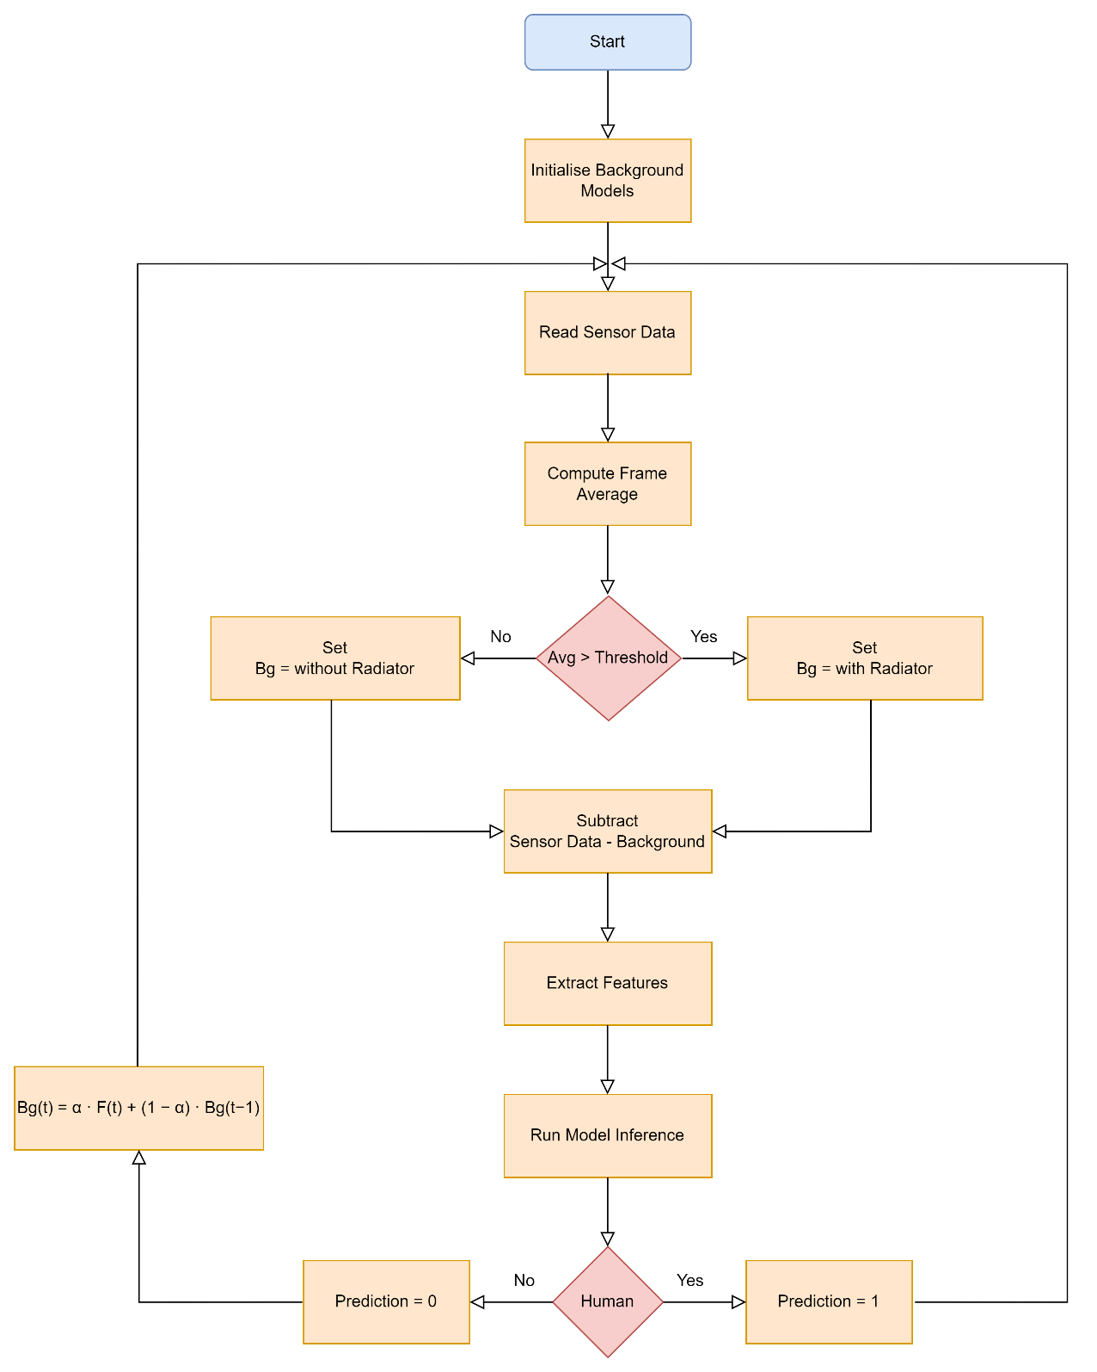

Figure 13: Real Time Inference Flow

## Performance Validation

To evaluate the performance of the proposed human presence detection system, a comparative analysis was conducted between a traditional PIR sensor-based setup and the developed machine learning-based thermal presence detection system deployed on a Raspberry Pi. Both systems were tested under identical conditions and evaluated based on detection accuracy, response time, and reliability.

### PIR Sensor Setup and Measurement

A standard PIR sensor with an integrated relay output was used as the baseline system. Since the relay did not have an onboard power source for signaling, a 9V battery was connected to the circuit to provide a visible voltage change upon relay activation. A 10kΩ current-limiting resistor was placed in series between the relay output and the oscilloscope probe.

As shown in Figure 9, the oscilloscope probe was connected across the relay output terminals to monitor the PIR sensor’s digital switching behavior. When motion was detected, the relay closed the circuit, connecting the signal line to the 9V battery’s positive terminal and generating a clear rising edge on the oscilloscope. Once the configured delay elapsed, the relay returned to its open state, and the signal dropped back to zero due to the open contact.

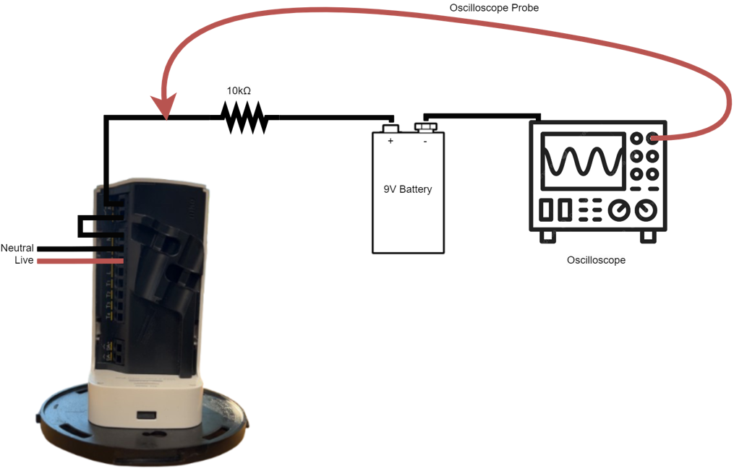

Figure 14: PIR Sensor Relay Output Test Setup

The relay switching time was configured via software tools to produce a 1-second ON duration for every valid motion detection event. This resulted in consistent pulse widths during oscilloscope monitoring, enabling accurate visualization of event timing and comparison. All detection events were manually verified against a ground truth log maintained during testing.

### Thermal Sensor-Based Detection and Logging

The second setup involved the proposed **machine learning-based thermal presence detection system**, implemented using a Raspberry Pi connected to an Omron D6T-32L thermal sensor. This setup was designed to detect human presence in real time using a trained Temporal CNN model that processes sequences of thermal frames to identify heat signatures indicative of human occupancy.

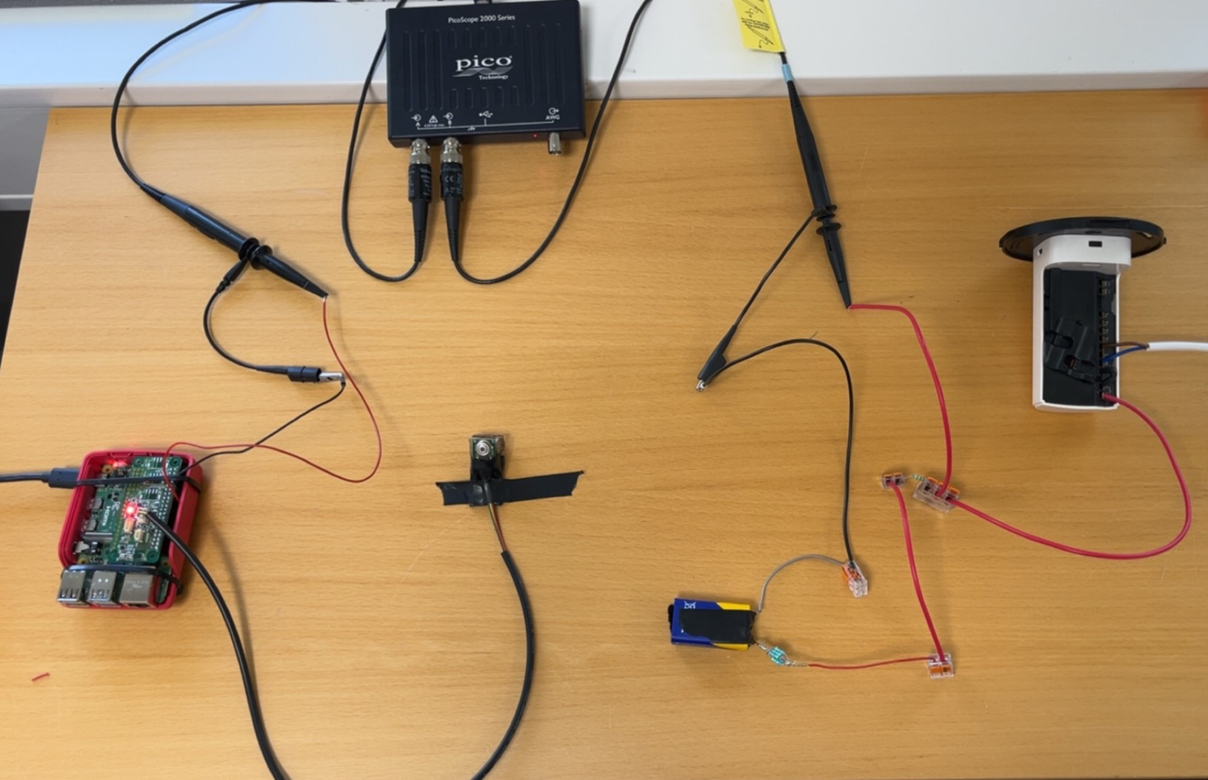To facilitate objective performance validation and enable accurate timing comparisons with the PIR sensor system, the Raspberry Pi was configured to toggle a digital output signal through **GPIO pin 18**. This pin was programmed to switch **HIGH** whenever the model confidently detected a human presence. The pin was connected to a **second oscilloscope channel**, allowing for simultaneous monitoring of both the thermal system and the PIR relay signal.

Figure 15: Combined Setup for both systems

This dual-channel measurement approach enabled direct visualization and comparison of detection events, including the timing of rising and falling edges, detection duration, and relative delay between the two systems. The synchronized signals provided a robust framework to evaluate **response time**, **missed detections**, and **false positives** across controlled test scenarios.

The integration of oscilloscope-based signal logging, GPIO output signaling, and thermal inference logging ensured a reliable and high-resolution data acquisition mechanism. This setup enabled comprehensive temporal alignment between predicted presence events and ground truth observations, forming the basis for calculating detailed performance metrics for both systems. Figure 10 Shows the desired setup

### Test Scenarios and Rationale

To validate the performance of both the PIR sensor system and the developed machine learning-based thermal presence detection system, a set of controlled test scenarios were designed. Each scenario was intended to simulate a representative use case and evaluate the detection behavior of both systems under consistent environmental conditions.

The experiments were conducted in a closed indoor environment with stable lighting and ambient conditions. The thermal sensor was positioned near the entrance to align its field of view with the PIR sensor, ensuring a shared detection zone. Both systems were operated in parallel, and detection events were logged synchronously using a dual-channel oscilloscope setup. Ground truth annotations were manually recorded to enable comparison between actual events and system outputs.

Three scenarios were evaluated:

* **Entry and Exit:** A person entered, briefly occupied the detection zone, and exited. This scenario was repeated to evaluate detection responsiveness and consistency.
* **Static Presence:** A person entered the detection zone and remained stationary for several minutes to assess the systems' ability to maintain detection in the absence of motion.
* **No Movement:** The room was kept unoccupied for a fixed duration to assess each system’s susceptibility to false triggering in the absence of motion or human presence.

These test cases collectively captured typical operational challenges in presence detection applications and were instrumental in highlighting differences in sensitivity, stability, and reliability between the two systems.

### Performance Metric Development

Performance evaluation was conducted using standard classification metrics derived from the confusion matrix framework. Sensor responses across all test scenarios were categorized into four classes: true positives (TP), false positives (FP), false negatives (FN), and true negatives (TN). These classes formed the basis for calculating the following metrics as shown in Table 6 below:

Table 6: Key Performance Metrices

|  |  |  |
| --- | --- | --- |
| **Metric** | **Formula** | **Description** |
| Accuracy | (TP + TN) / (TP + FP + TN + FN) | Overall correctness of the detection system |
| Precision | TP / (TP + FP) | Proportion of positive detections that were correct |
| Recall (Sensitivity) | TP / (TP + FN) | Proportion of actual presences correctly identified |
| F1 Score | 2 × (Precision × Recall) / (Precision + Recall) | Harmonic mean of precision and recall |
| False Positive Rate | FP / (FP + TN) | Frequency of incorrect detections when no one was present |
| False Negative Rate | FN / (FN + TP) | Frequency of missed detections during actual presence |
| Response Time | Mean (Time of Detection – Time of Entry) | Time delay between actual presence and system response |

Metric values were computed using synchronized oscilloscope traces and software-based timestamp logs. The results provided a quantitative basis for comparing the performance of the PIR and thermal sensor-based detection systems and evaluating the operational benefits of the proposed approach.

## Model Adaptation and Deployment on ESP32-S3

The primary objective of this thesis was to develop a robust machine learning model for accurate human presence detection using thermal data. This was successfully achieved through the implementation and evaluation of a temporal CNN model deployed on a Raspberry Pi. After meeting the core objectives, the scope of the work was extended to explore the feasibility of deploying the presence detection system on resource-constrained edge devices.

This extension reflects a growing interest in real-world applications such as smart buildings and IoT systems, where running machine learning models on low-power, embedded hardware is essential. Several platforms were considered for this purpose, including Silicon Labs MG24, STM32 series, and ESP32. Among these, the ESP32-S3 was selected due to its balance of hardware AI acceleration support, active open-source toolchain, and significantly lower cost, making it ideal for scalable deployment in cost-sensitive applications.

Specifically, the ESP32-S3-DevKitC-1-N32R8V development board was used, featuring the ESP32-S3 SoC with dual-core Xtensa 32-bit LX7 processors (up to 240 MHz), 512 KB of SRAM, 8 MB of external PSRAM, and 32 MB of Octal SPI flash memory. These hardware resources provide enough capacity for running lightweight neural networks, while maintaining ultra-low power consumption; a crucial factor in battery-powered and continuously active environments.

However, the original temporal CNN model—consisting of over 200,000 parameters and utilizing layers such as **Time Distributed**, **Conv1D**, and **GlobalAveragePooling1D** were not compatible with Espressif’s ESP-DL inference engine, which only supports a subset of layers optimized for efficient deployment on microcontrollers. This limitation required a redesign of the original architecture.

To enable successful deployment, a simplified CNN model was developed using only ESP-DL-supported layers such as Conv2D, MaxPooling2D, and Dense as shown in Table 7 below. The adapted model significantly reduced the parameter count and computational load, while still achieving reliable performance for presence detection. The model yielded an accuracy of **98.13%** on training dataset. This demonstrates that even on low-cost and resource-constrained devices, it is possible to run real-time inference effectively; expanding the solution’s applicability to edge-based IoT environments.

Table 7: Adapted CNN Model Architecture for ESP32-S3 Deployment

|  |  |  |
| --- | --- | --- |
| **Layer Description** | **Type** | **Output Shape** |
| Input | Input Layer | (None, 32, 32, 1) |
| Convolution 1 | 2D Convolution (8 filters) | (None, 32, 32, 8) |
| Pooling 1 | Max Pooling (2×2) | (None, 16, 16, 8) |
| Convolution 2 | 2D Convolution (16 filters) | (None, 16, 16, 16) |
| Pooling 2 | Max Pooling (2×2) | (None, 8, 8, 16) |
| Convolution 3 | 2D Convolution (32 filters) | (None, 8, 8, 32) |
| Pooling 3 | Max Pooling (2×2) | (None, 4, 4, 32) |
| Global Average Pooling | Pooling across spatial dims | (None, 32) |
| Fully Connected (Hidden) | Dense layer with ReLU | (None, 32) |
| Dropout | Regularization (rate = 0.3) | (None, 32) |
| Output | Dense layer with Softmax | (None, 2) |

### Model Quantization and Deployment Workflow

After training and validating the simplified CNN model, the next step involved preparing it for deployment on the ESP32-S3 microcontroller by converting it into a quantized format suitable for embedded inference. This process began with exporting the trained Keras model to the ONNX (Open Neural Network Exchange) format using the tf2onnx conversion tool. This format served as an intermediate representation compatible with Espressif’s quantization pipeline.

To enable proper calibration during quantization, a portion of the model’s test dataset was serialized using Python’s pickle module. This calibration dataset was used by Espressif’s quantization tool, which applied INT8 quantization using a per-tensor min-max calibration strategy. The quantization process generated two essential output files: Presence.cpp and Presence.h, which encapsulated the model weights and structure in a format that could be integrated into ESP-DL’s C++ inference engine.

These coefficient files were then integrated into a C++ application using ESP-DL’s template. The integration process involved defining the input and output tensor shapes, setting the correct quantization exponents, and linking the model's input data to GPIO or memory buffers. Output handling was configured through UART serial output or GPIO pin toggles for debugging purposes.

Finally, the complete inference application was compiled using ESP-IDF and flashed onto the ESP32-S3-DevKitC-1-N32R8V board. The deployed model was tested using synthetic thermal data inputs to verify that inference ran correctly on-device. This successful deployment validated the model’s compatibility with the ESP32-S3 platform and demonstrated the feasibility of real-time, embedded human presence detection on a low-cost microcontroller.

### Sensor Integration with ESP32

# Results and Analysis

## Training and Validation Results

The final model used in this thesis was a Temporal CNN designed to process five sequential thermal frames for human presence detection. It was trained for three epochs using the Adam optimizer with a learning rate of 0.0005 and sparse categorical cross-entropy loss. The results indicate rapid and stable convergence, with minimal overfitting and outstanding generalization.

The training and validation accuracy trends are shown in Figure 11, and the loss curves are depicted in Figure 12. The model achieved a training accuracy of 99.8% and a validation accuracy of 99.9% by the third epoch. The loss dropped significantly from an initial 0.3748 to 0.0064 on the training set and 0.0062 on the validation set, demonstrating smooth and consistent learning behavior. To further validate the model’s generalization, it was evaluated on a separate test dataset. The final test accuracy was recorded at 99%, confirming that the model maintained high performance on unseen data and could reliably classify human presence across a variety of scenarios.

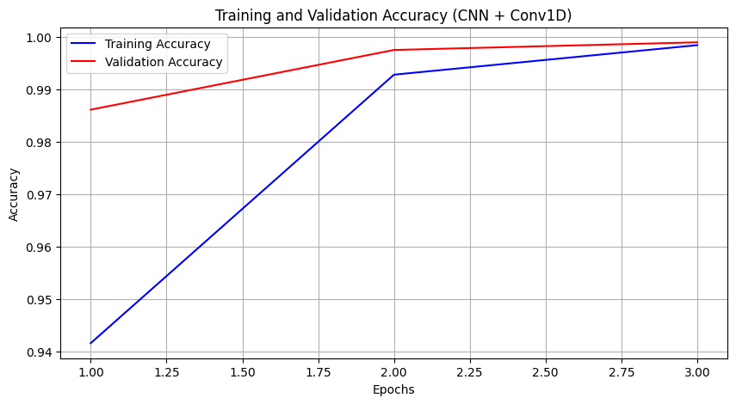

Figure 16: Training and Validation Accuracy

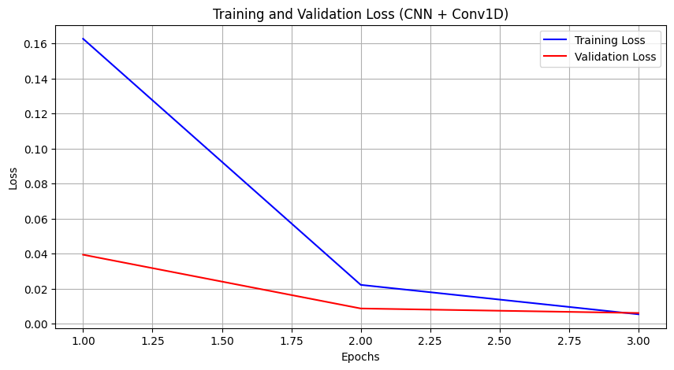

Figure 17: Training and Validation Loss

## Model Performance on Test Data

To assess the generalization ability and real-world readiness of the proposed Temporal CNN model, its performance was evaluated on a separate **test dataset** consisting of thermal frames not used during training or validation. This dataset was designed to replicate diverse and challenging ambient conditions, including background heat sources, lighting changes, and varying occupancy patterns. Such diversity ensures a rigorous assessment of the model’s robustness in real deployment scenarios.

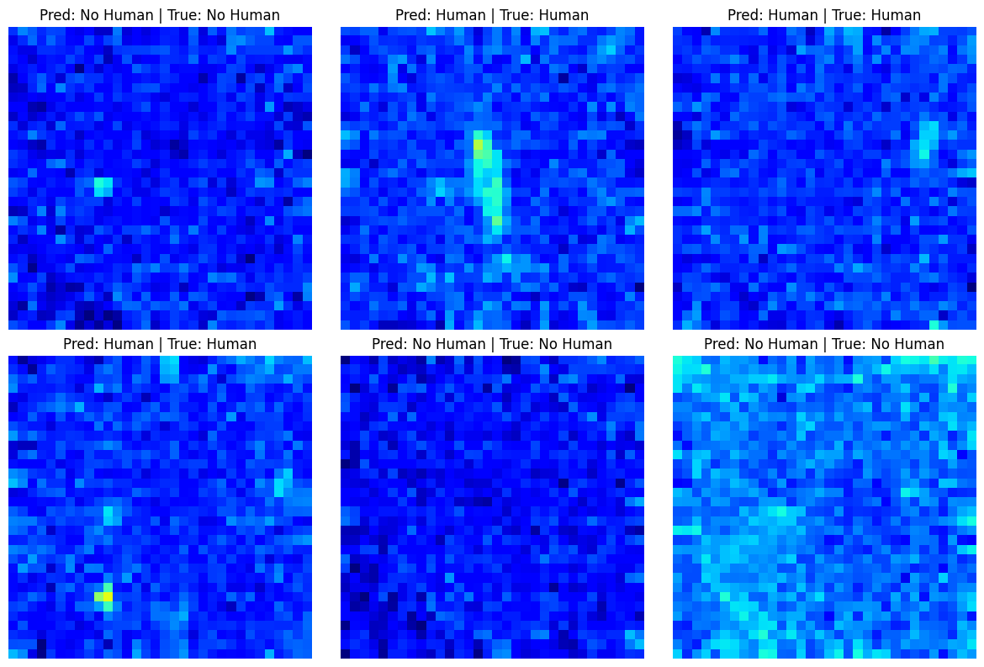

Figure 18: Model Prediction on Test Dataset

Figure 13 showcase representative predictions made by the model on individual test frames. Each image is labeled with the predicted class and the ground truth. The visualizations demonstrate the model’s strong ability to distinguish between “Human” and “No Human” classes with high confidence.

In cases where human presence was subtle, such as small or partially occluded thermal signatures, the model correctly identified activity. Conversely, for scenes with ambient heat but no actual presence, the model avoided false positives. These qualitative results provide an intuitive understanding of the model’s discriminative power and thermal feature extraction capabilities.

To further quantify the model's performance on the test dataset, a confusion matrix was generated using all 6,844 test samples, evenly distributed between the “Human” and “No Human” classes. As shown in Figure 14, the model correctly classified 3,366 “Human” instances and 3,417 “No Human” instances, resulting in only 5 false positives and 56 false negatives. This indicates that the model possesses high sensitivity and specificity, with only a marginal number of misclassifications, mostly arising in borderline thermal conditions.

These results collectively demonstrate that the Temporal CNN model is both accurate and reliable, making it well-suited for real-time human presence detection in diverse and dynamic indoor environments.

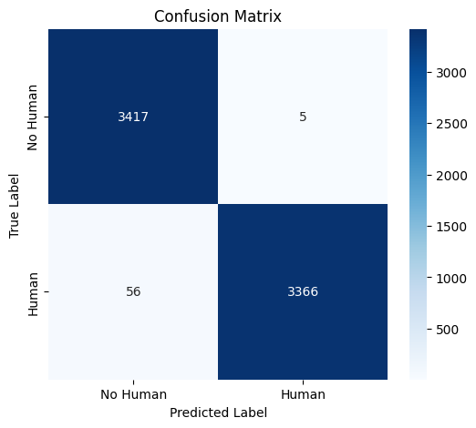

Figure 19: Confusion Matrix for Temporal CNN Model

## Model Performance Comparison

Table 8 presents a comparison of the three candidate models explored in this work: the proposed Temporal CNN, a 1D CNN, and a Multi-Layer Perceptron (MLP). The models are compared in terms of parameter size, training accuracy, validation accuracy, and test accuracy to assess their learning capacity, generalization ability, and suitability for deployment on edge devices.

The Temporal CNN, which was ultimately selected for deployment, achieved the highest performance across all evaluation metrics. It reached a training accuracy of 99.7%, a validation accuracy of 99.94%, and a test accuracy of 99%, demonstrating strong generalization and robustness. With a relatively compact parameter count of 200,000, this model efficiently captured both spatial and temporal features from thermal input sequences, making it ideal for real-time presence detection.

The 1D CNN achieved high training accuracy (99.4%) but exhibited weaker validation (96%) and test accuracy (90%). While the model performed reasonably well on curated validation data, its accuracy dropped significantly on the test set and even more during live inference scenarios. This reduction can be attributed to the lack of spatial feature extraction, as 1D CNNs operate across a single temporal axis and are not designed to capture two-dimensional spatial patterns present in thermal images. Moreover, the 1D CNN had the highest parameter count at over 1 million, making it less efficient for real-time embedded deployment.

The MLP model showed the weakest performance among the three, with a training accuracy of 94.47%, validation accuracy of 88.15%, and test accuracy of only 80%. Although it had the fewest parameters (33,000), the MLP struggled with both learning complex patterns and generalizing to new data. Its fully connected architecture, lacking any form of local receptive field, proved insufficient for spatial reasoning which is a key requirement in thermal-based human detection.

This analysis underscores the trade-offs between model complexity, accuracy, and inference reliability. While the 1D CNN offered moderate generalization, its inability to extract spatial features and its performance drop under real-world conditions limited its practical use. On the other hand, the Temporal CNN, by leveraging temporal and spatial encoding, delivered excellent performance with a balanced model size, making it the most suitable choice for resource-constrained, real-time presence detection systems.

Table 8: Comparison of Model Performance Metrices

|  |  |  |  |  |
| --- | --- | --- | --- | --- |
| Models | Model Parameters | Training Accuracy | Validation Accuracy | Test Accuracy |
| Temporal CNN | 200,000 | 99.7 | 99.94 | 99 |
| 1D CNN | 1,061,954 | 99.4 | 96 | 90 |
| MLP | 33,000 | 94.47 | 88.15 | 80 |

## Real-Time Background Adaptation and Static Heat Suppression

Figure 15 and 16 illustrates two distinct real-time inference scenarios that demonstrate the behavior of the adaptive background removal mechanism. In the first case (Figure 15), the room remains unoccupied, and the system steadily learns the ambient thermal background. As shown in the background adaptation plot, the updated background model (blue curve) gradually converges toward the real background (red curve) using Exponential Moving Average (EMA) smoothing, while the stored background (black dashed line) remains unchanged. The corresponding thermal heatmap confirms a “No Human” prediction with high confidence, reinforcing the model’s decision to continue updating the background.

One of the key observations in this scenario is that the system typically requires approximately 60 consecutive frames to fully adapt to a static environment. Given that the thermal sensor operates at 5 frames per second, this equates to an adaptation time of 12 seconds. This duration has been empirically validated to be sufficient for the background model to align with the actual thermal baseline of the room, especially in the presence of static heat sources such as radiators or electronics. It provides an effective trade-off between rapid adaptation and resilience to transient noise.

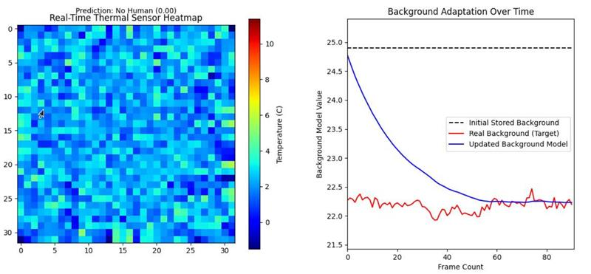

Figure 20: Continuous Learning in Static Environment

In the second scenario (Figure 16), the system begins adapting under no-human conditions. However, when a human enters the room, the model halts adaptation; seen as a plateau in the blue curve to prevent incorporating human heat signatures into the background. Once the person leaves and the system confidently returns to a “No Human” state, the background learning resumes automatically.

What distinguishes this approach from previous methods, such as the one proposed by Kim et al. [8], is its dual-background initialization and dynamic model switching strategy. While Kim et al. rely on a static, precomputed background subtraction approach, the system developed in this thesis preloads two environment-specific background models: one tailored for rooms with heaters turned on and another for heater-off conditions. During live inference, the average ambient temperature is calculated in real-time and used to select the most appropriate background model, after which adaptive learning begins. This not only improves accuracy in variable heating conditions but also adds seasonal robustness and thermal flexibility to the detection pipeline.

By updating the background model only during confident “No Human” intervals and customizing it based on environmental context, the system achieves a level of environmental awareness and adaptability that is not addressed in existing static background methods.

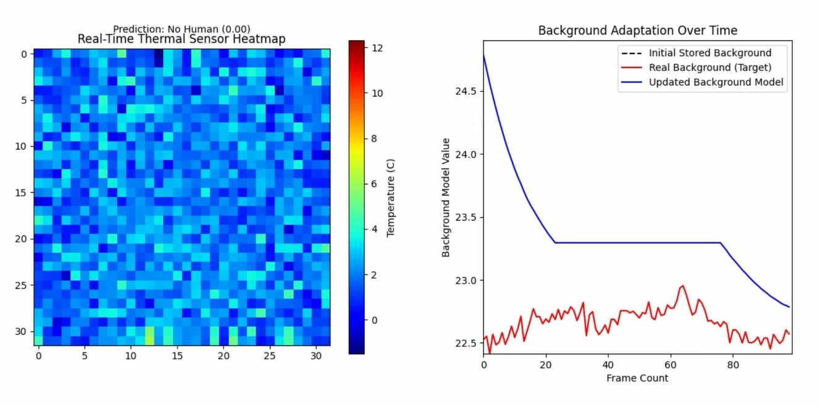

Figure 21: Learning Interrupted and Resumed around Human Presence

Overall, the results confirm that the proposed adaptive background mechanism is highly effective for real-time inference, enabling the system to maintain long-term stability and reduce false detections in both occupied and unoccupied indoor environments.

## Real Time Inference Results on Raspberrypi

To evaluate the effectiveness of the system in live deployment scenarios, a series of real-time inference tests were conducted under various indoor environmental conditions. These tests aimed to assess the system’s ability to detect human presence both before and after applying the adaptive background removal technique.

### Scenario 1: No Heater – Open Room Environment

In the first setting, the system was deployed in a standard office room measuring approximately 2.5 meters by 4.5 meters. The environment was free of major heat-emitting devices, and the heater was turned off. There was only one Laptop and 2 mobile phones in this setting. As a human walked into the room, the system was able to detect their presence reliably within a 3-meter range which matches the maximum effective sensing distance of the Omron D6T-32L-01A thermal sensor. The thermal heatmap, combined with visual inspection, confirmed accurate prediction aligned with real-world presence as shown in Figure 17 below.

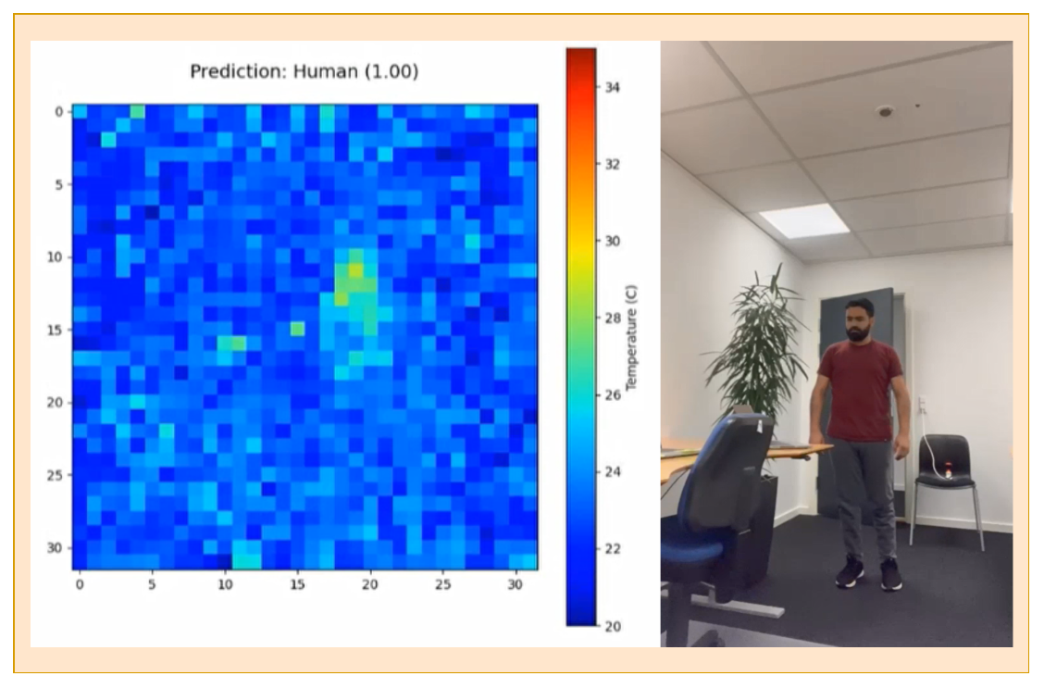

Figure 22: Human Presence Detection in Office Room

### Scenario 2: Heater and Plumbing Heat – Washroom Environment

The second test was performed in a 2×2-meter washroom where multiple background heat sources were present, including an active wall-mounted heater and a hot water pipe. Despite this thermal noise, the system successfully differentiated between static background heat and human presence. When the room was unoccupied, the system correctly predicted “No Human,” and it shifted to “Human” only upon actual presence. This showed that even in thermally cluttered environments, the baseline CNN model was able to retain a fair level of robustness as shown in Figure 18.

### Scenario 3: High Heat Source with Background Removal Concept

Following these baseline tests, the adaptive background removal strategy was applied to enhance robustness. This approach enabled the system to subtract static heat signatures and focus only on transient thermal changes likely caused by human presence. The system was tested in a 3×3-meter bedroom equipped with multiple active devices, including a TV, laptop, lamp, and radiator.

In this case, the model's thermal input range shifted from broader ambient values to a more refined differential temperature scale (0 to 6°C). As shown in Figure 19, the system successfully suppressed static heat sources such as the heater and background electronics. Upon human entry, the thermal contrast became immediately distinguishable, and the prediction shifted with high confidence to “Human.” The post-adaptation inference demonstrated increased clarity, stronger contrast in heat signatures, and reduced false positives, confirming that background modeling significantly improved real-time robustness.

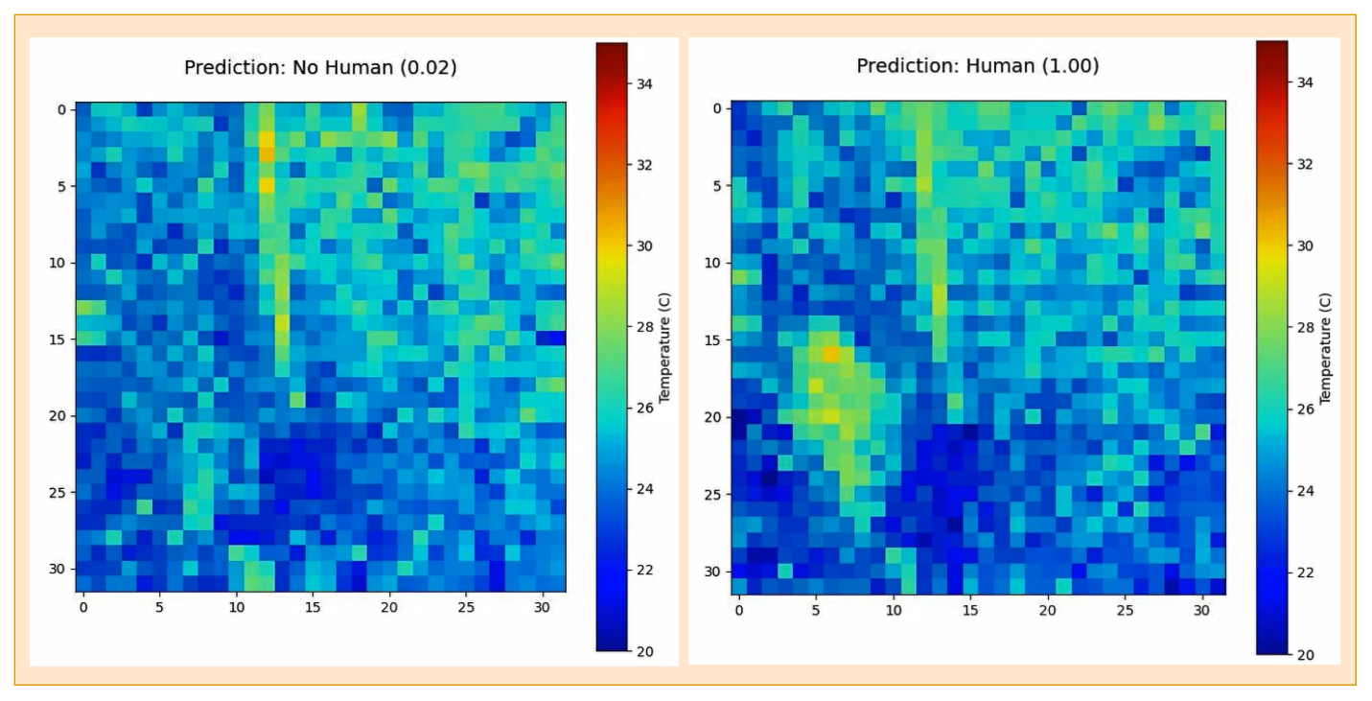

Figure 23: Reliable detection in a washroom with Different Heat Sources

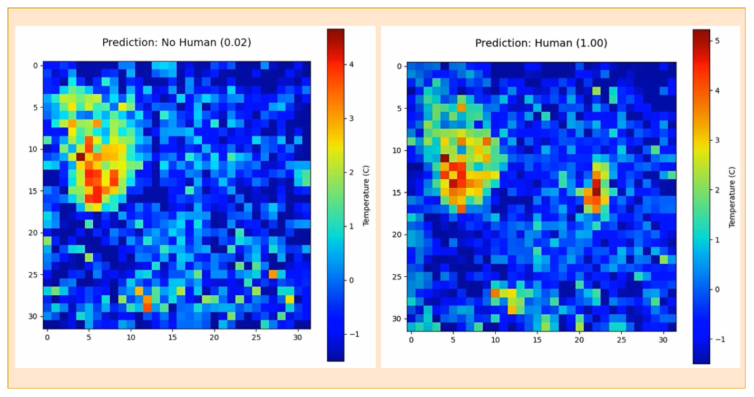

Figure 24: Post-background-adaptation detection in a bedroom with multiple heat sources

## Performance Evaluation of Presence Detection Systems

This section presents a scientific evaluation of the proposed thermal presence detection system against the conventional Passive Infrared (PIR) sensor-based approach. The comparison is based on accuracy, response time, sensitivity, and reliability under standardized test scenarios described in Section 2.7. The assessment is designed to validate the thesis objective of establishing the thermal system’s performance superiority, particularly for continuous and low-motion detection contexts.

### Detection Responsiveness in Entry/Exit Scenarios

A dynamic entry/exit experiment was conducted to assess the temporal responsiveness of both systems. In each trial, a person entered the room, remained briefly, and then exited. Detection timing was measured using binary signal traces and synchronized oscilloscope logging. Figure 20 displays binary output plots of PIR and thermal systems over ten test iterations. Quantitative rise times were extracted to determine detection latency. The PIR system consistently activated before the thermal system, resulting in a mean lead time of 1.73 seconds (Table 9). This advantage arises from the PIR sensor’s instantaneous response to movement-induced infrared changes. However, signal traces in Figure 20 reveal that PIR detection was transient frequently dropping during stationary intervals.

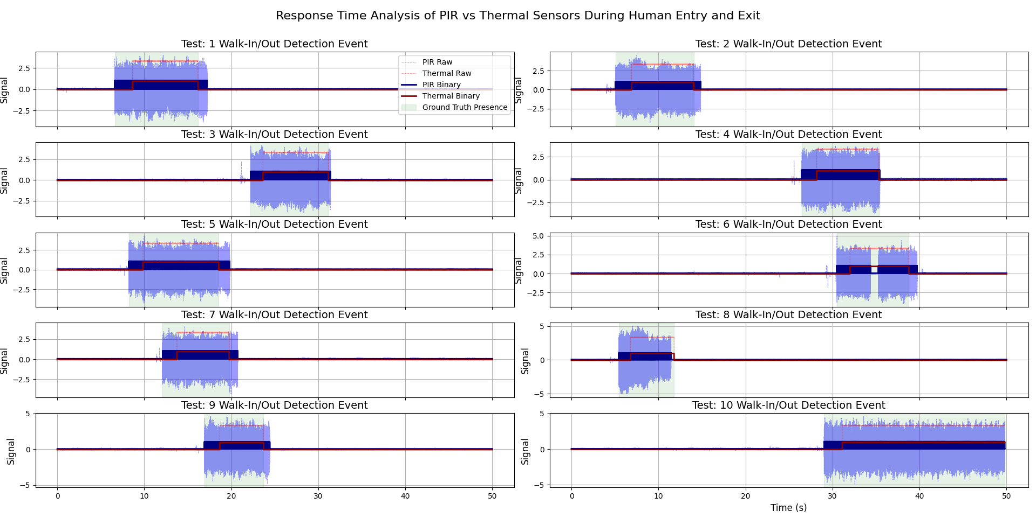In contrast, the thermal system demonstrated high detection persistence across the presence window by leveraging spatial thermal gradients captured by its 32×32 array. This allowed it to maintain a consistent logical high state despite fluctuations in Human movement. A detailed, high-resolution version of the signal traces shown in Figure 20 is available in **Appendix C (Figure C.1)** for closer inspection of PIR and thermal detection behavior.

Figure 25: Response Time Analysis of PIR vs Thermal Sensor

The results reveal a critical trade-off: PIR sensors provide faster detection at entry but lack temporal continuity, while the thermal system offers slightly delayed but stable presence tracking. These characteristics establish the thermal system as more suitable for applications requiring continuous presence awareness, such as adaptive lighting or smart HVAC control.

Table 9: Rise Time and Response Delay Comparison Between PIR and Thermal Sensors.

|  |  |  |  |
| --- | --- | --- | --- |
| Test # | Thermal Rise Time (s) | PIR Rise Time (s) | Response Delay (PIR - Thermal) (s) |
| 1 | 8.64 | 6.59 | -2.05 |
| 2 | 6.90 | 5.06 | -1.84 |
| 3 | 23.63 | 22.22 | -1.41 |
| 4 | 28.18 | 26.47 | -1.71 |
| 5 | 9.84 | 8.21 | -1.64 |
| 6 | 32.01 | 30.49 | -1.53 |
| 7 | 13.74 | 12.11 | -1.64 |
| 8 | 6.77 | 5.43 | -1.35 |
| 9 | 18.66 | 16.89 | -1.77 |
| 10 | 31.12 | 29.04 | -2.09 |

### Detection Reliability in Static Presence Scenarios

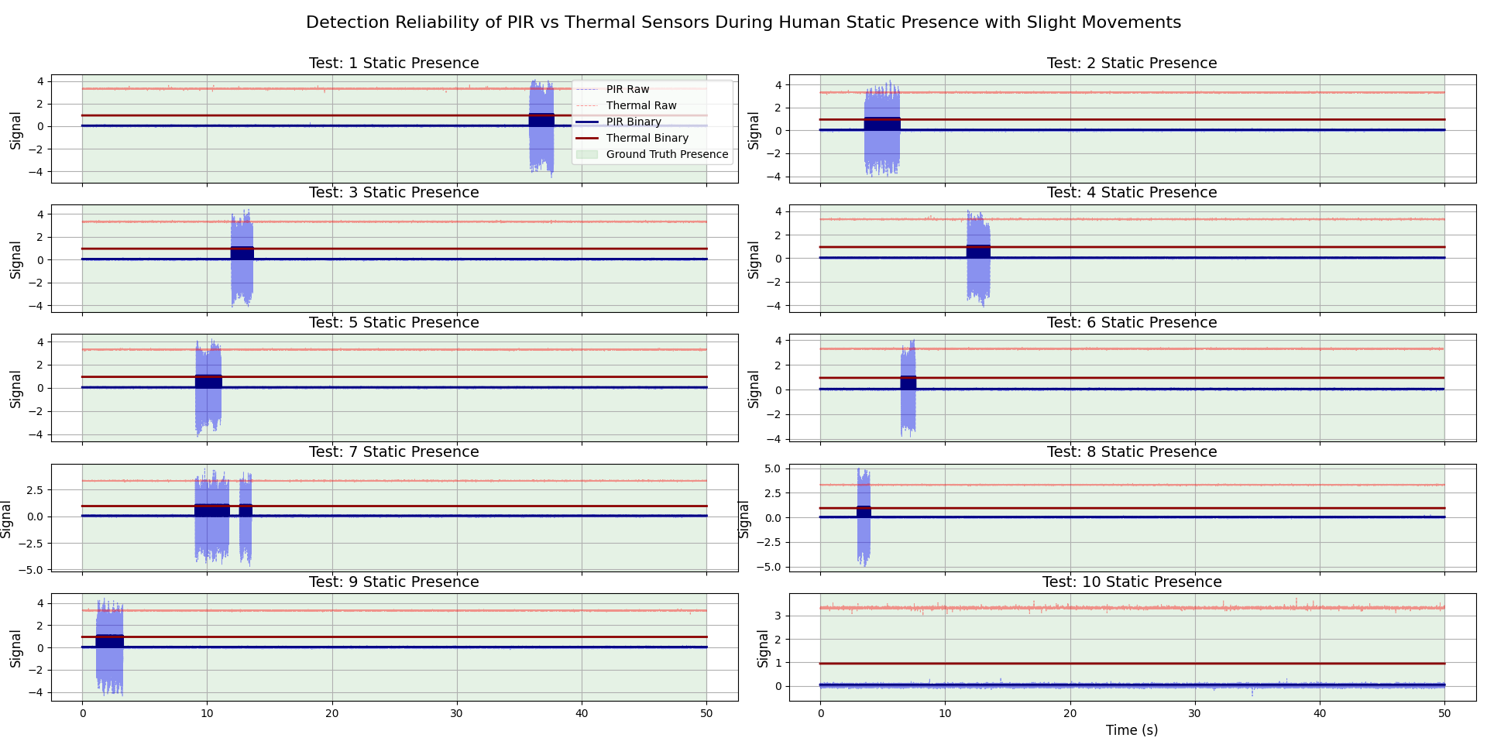To evaluate sensor performance under low-movement conditions, a static presence scenario was designed where a person remained seated with occasional micro-movements. Figure 21 illustrates detection behavior for both systems across ten trials.

Figure 26: Detection Reliability of PIR vs Thermal Sensor During Static Presence

The thermal system sustained continuous detection throughout the presence interval, confirming its robustness to minimal motion. Conversely, the PIR system frequently reverted to its idle state when no motion was detected, resulting in intermittent detection and a high false negative rate. This limitation reflects the PIR system’s dependency on dynamic motion to trigger detection. The thermal system, by contrast, accurately captured subtle heat signatures without requiring abrupt changes. This consistency is crucial for use cases involving prolonged occupancy with minimal motion.

### False Trigger Analysis in No Presence Scenarios

Figure 22 shows the detection reliability of the PIR and thermal sensing systems during two separate tests conducted in an empty room. This scenario simulates an idle environment with no human presence. In both tests, the binary traces for each system remain consistently below their detection thresholds, with no unexpected spikes or activations. This confirms that neither system produced any false positives, demonstrating strong stability and environmental immunity under no-presence conditions. System’s False Triggering performance was evaluated by monitoring both systems in an unoccupied room which was left running for several hours. This robustness enhances suitability in high-reliability applications, including security monitoring and home automation.

### Comparative Performance Metrices

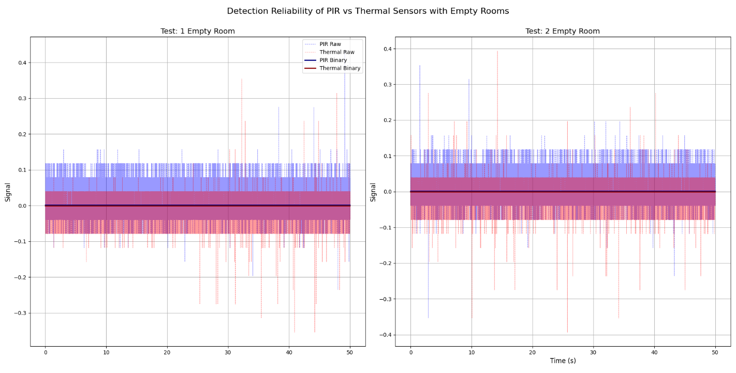

Figure 27: Detection Reliability with no Human Presence

To comprehensively evaluate the detection performance of both presence detection systems, standard classification metrics were calculated across all test scenarios using ground truth annotations. These metrics, derived from the confusion matrix framework, include Accuracy, Precision, Recall, F1 Score, False Positive Rate (FPR), and False Negative Rate (FNR). The results were averaged across all trials and summarized in Figure 23.

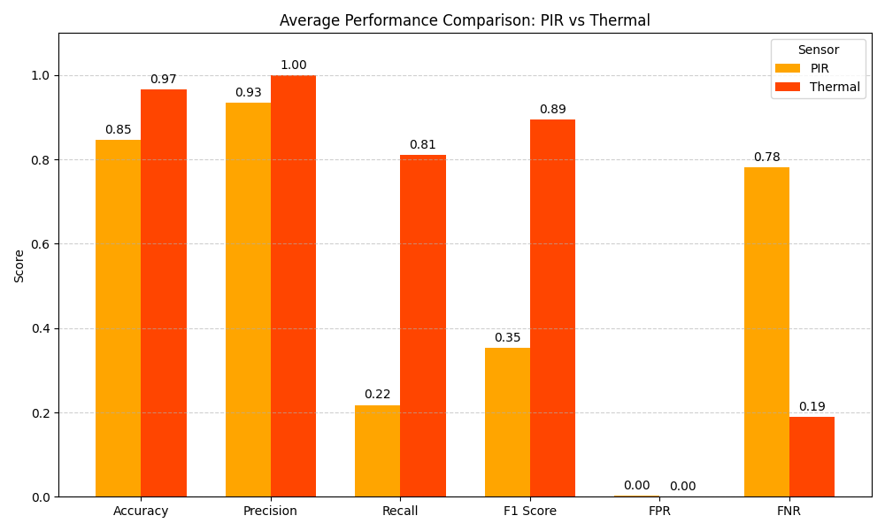

Figure 28: Performance Comparison between PIR and Thermal based Systems

The thermal detection system outperformed the traditional PIR sensor across all key performance indicators. Notably, the thermal system achieved:

* **Higher Accuracy**: Reflecting overall correctness, thermal sensing reached a superior average accuracy, indicating fewer misclassifications over all conditions.
* **Perfect Precision and Recall**: The system consistently detected true positives with no false alarms (precision = 1.0), and reliably captured all actual presences (recall ≈ 0.81), particularly excelling in static and low-motion scenarios.
* **Higher F1 Score**: The harmonic mean of precision and recall was substantially higher for the thermal sensor, signifying a balanced and effective detection capability.
* **Low False Negative Rate**: While the PIR system exhibited a high FNR, primarily due to its inability to sustain detection during static presence, the thermal system maintained a low FNR, ensuring minimal missed detections.
* **Negligible FPR in Both Systems**: Both sensors demonstrated good baseline stability in no-presence scenarios, yielding near-zero FPR.

These quantitative results corroborate the earlier time-series and oscilloscope-based findings. The PIR system is best suited for scenarios with dynamic human movement due to its rapid activation, but it struggles with continuity and sensitivity under low-motion or static conditions. In contrast, the thermal system demonstrated robust and sustained performance across all use cases, especially in challenging low-motion detection scenarios. This evaluation clearly demonstrates the operational advantages of the proposed thermal presence detection method. It validates the system’s capacity to deliver improved detection accuracy, higher efficiency, and enhanced reliability, effectively meeting the thesis objective of outperforming traditional PIR sensors. These improvements are particularly impactful for applications where continuous presence awareness, energy optimization, or adaptive automation are essential.

## Embedded Inference of ML Model on ESP32-S3

After adapting the original model to meet the layer constraints of the ESP-DL framework, a simplified CNN was successfully quantized using INT8 per-tensor quantization and deployed on the ESP32-S3 microcontroller. The quantized model achieved an impressive classification accuracy of 96.06%, only slightly lower than its floating-point counterpart at 97.45%, indicating that performance degradation due to quantization was minimal. The deployment generated two lightweight coefficient files (Presence.cpp and Presence.hpp) which encapsulated the quantized weights, biases, and layer-wise exponent values (as detailed in Figure 29) in a C++ compatible format.

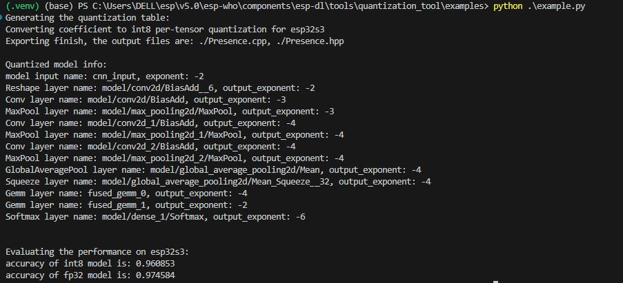

Figure 29: Quantization summary and exponent scaling per layer

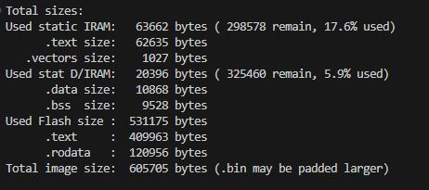

Figure 30: Memory usage statistics for ESP32-S3 deployment

These files were integrated into a C++ inference application compiled using the ESP-IDF framework. The final firmware build consumed only 605,705 bytes of flash, with 17.6% IRAM and 5.9% DRAM usage, as shown in Figure 30, confirming that the model runs comfortably within the ESP32-S3’s memory limits. These results demonstrate the feasibility of deploying accurate, real-time machine learning models on ultra-low-power microcontrollers.

## Experimental Validation on ESP32-S3 Using Thermal Input Frames

To empirically evaluate the deployed model’s inference capabilities under operational conditions, the quantized CNN was tested in real time on the ESP32-S3 microcontroller interfaced with a 32×32 thermal imaging sensor. The embedded inference pipeline was implemented in C++ and executed within the ESP-IDF framework, classifying each incoming thermal frame into binary classes: 0 (no human presence) and 1 (presence detected).

Validation was conducted using live thermal streams captured under controlled environmental settings across three representative scenarios:

* A vacant room (no occupants),
* Partial human presence in the field of view,
* Full-body presence with natural movement.

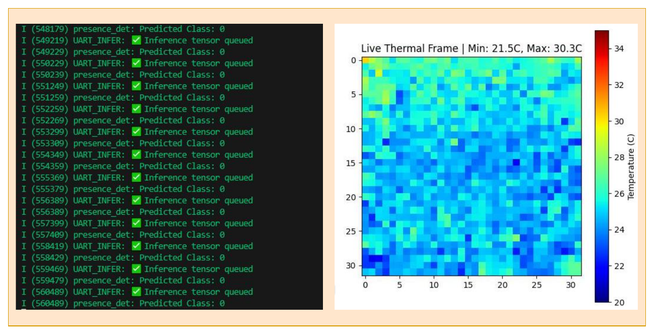

Figure 31: No Human Presence with ESP32

Figure 31 illustrates a representative example from the no-presence condition. The thermal frame exhibits a uniform background temperature distribution with no significant thermal anomalies, and the model consistently predicts class 0 with high confidence despite of many different heat sources being around like laptops and monitors.

In contrast, Figure 32 corresponds to a scenario with active human presence. Localized high-temperature regions (31–36 °C) are distinctly visible in the thermal map, and the model outputs class 1 across all captured frames, indicating successful recognition of occupancy.

These results substantiate the model’s ability to perform robust classification on-device using raw thermal data without reliance on preprocessing steps such as background subtraction. The decision to omit background removal was deliberate, as such operations introduce additional computational complexity and memory overhead, which are impractical for constrained embedded platforms like the ESP32-S3.

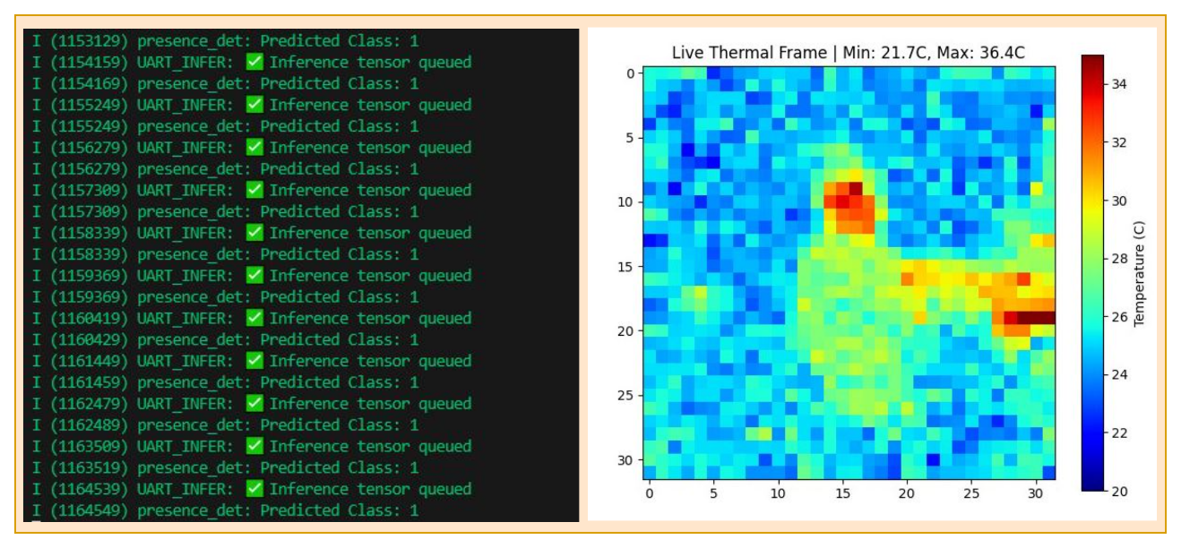

Figure 32: Human Presence with ESP32

Despite minor fluctuations in prediction around the thermal edges—particularly in frames with occlusion or weak thermal contrast—the system maintained consistent classification performance. Real-time inference was achieved with minimal latency, and the observed deviations did not compromise the model’s practical applicability.

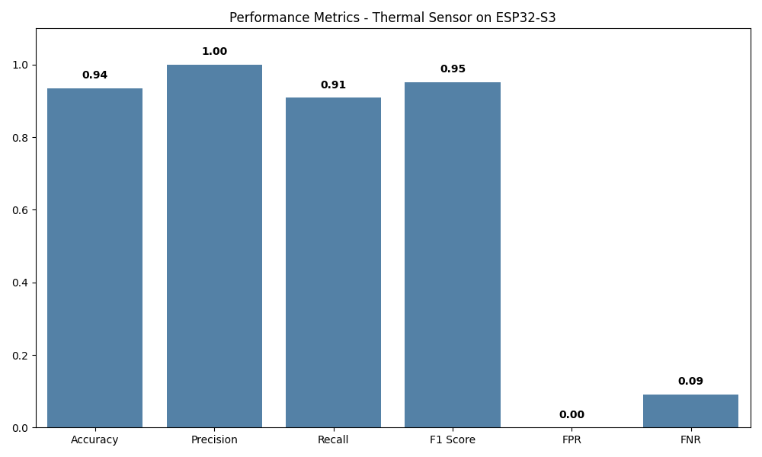

Figure 33: Performance Metrices for Model deployed on ESP32

To further quantify this performance, a live test stream was processed and evaluated using multiple frames. The results are summarized in the bar chart above (Figure 33), which reflects the system’s overall performance metrics. A comprehensive breakdown of individual inference cases; including predicted vs. expected labels and the corresponding classification outcome is provided in **Appendix D**.

When compared to the quantized INT8 model’s benchmark accuracy of **96.06%** obtained from offline evaluation (as reported in Section 3.7), the live inference results demonstrate only a slight degradation of ~2%. This marginal drop highlights the effectiveness of the quantization process, confirming that the model retains strong discriminative power even under real-time execution on resource-constrained embedded hardware.

Overall, the deployment illustrates the practical feasibility of embedding lightweight neural networks for presence detection using thermal sensors on ultra-low-power microcontrollers. The system's performance, both quantitatively and qualitatively, reinforces its readiness for integration into smart sensing applications such as energy-efficient lighting control, HVAC optimization, and adaptive occupancy monitoring.

# Discussion

This chapter discusses the main findings, strengths, limitations, and broader implications of the work presented. It interprets the results from Chapter 3 and situates them within the context of existing research and real-world application needs.

## Summary of Main Findings

The results demonstrate that the developed system successfully addressed the core objectives of the thesis. The Temporal CNN model achieved high classification accuracy, reaching approximately 99% test accuracy on unseen thermal frames. The model effectively generalized across varying environmental conditions, including idle rooms, thermally cluttered washrooms, and bedrooms with multiple static heat sources.

The adaptive background learning mechanism significantly improved system robustness by allowing continuous environmental adaptation without falsely integrating human heat signatures. Furthermore, real-time inference was achieved on a Raspberry Pi 4 platform with stable and responsive behavior. A lightweight version of the model was also successfully adapted and quantized for ESP32-S3 deployment, demonstrating high embedded feasibility despite hardware constraints.

Finally, comparative testing against PIR sensors showcased the superior reliability of thermal-based presence detection, especially in static human scenarios where PIR systems traditionally suffers to perform.

## Strengths of Proposed System

Several aspects of the developed system demonstrate its strong suitability for real-world deployment:

* **High detection robustness**: The model maintained accurate predictions across varied room sizes, heat profiles, and environmental noise conditions.
* **Privacy preservation**: Using low-resolution thermal data enabled human detection without compromising visual privacy, addressing a major concern associated with vision-based systems.
* **Embedded feasibility**: Achieving real-time inference on Raspberry Pi and initial adaptation on ESP32-S3 proves the system's low-power operational capability.
* **Adaptive background learning**: Unlike traditional static subtraction methods, the developed EMA-based dynamic background modeling allowed the system to "learn" the environment gradually, avoiding static heat misclassification.
* **Improved reliability over PIR**: The system successfully detected stationary individuals and suppressed false positives from environmental noise, where PIR sensors often fail.

## Comparison with Related Work

Compared to prior work such as Kim et al. (2022), which relied on static background subtraction techniques applied to thermal frames, this thesis introduced a real-time **adaptive background learning approach** using Exponential Moving Average (EMA). This advancement allowed the system to dynamically adapt to slow environmental changes without misclassifying static heat sources; a key limitation in prior static-background methods.

Furthermore, while earlier studies often demonstrated thermal ML models on high-power platforms such as desktop computers, this work successfully achieved **real-time inference on embedded devices** like the Raspberry Pi and ESP32-S3, demonstrating practical feasibility for low-cost, scalable deployment.

In contrast to human presence detection methods based on Wi-Fi Channel State Information (CSI) [Saleem et al., 2024] or RF sensing, which typically require extensive calibration and can face privacy concerns, this system offers **passive, privacy-preserving thermal sensing** without emitting or collecting identifiable data.

Importantly, the experimental validation conducted in this thesis extended beyond simple one-human detection scenarios. The system was tested under **multiple-human presence conditions** and **environmental thermal variations** such as **active radiators and heat sources**, demonstrating strong resilience to cluttered thermal backgrounds. These realistic test conditions go beyond many previous works that relied heavily on controlled, single-human environments.

In summary, the developed system achieves a balanced trade-off between **accuracy**, **privacy preservation**, **embedded deployability**, and **adaptability to dynamic, real-world environments**, positioning it as a competitive and practical alternative to PIR, RF-based, and static thermal-based human presence detection solutions.

## Limitations

Despite strong performance, some limitations remain:

* **Simplified model on ESP32-S3**: Due to hardware constraints, a relatively smaller CNN variant could be deployed, slightly reducing classification robustness compared to the full Temporal CNN.
* **Limited environmental variability**: Tests focused primarily on indoor spaces with moderate variability; extreme cases like heavy moving crowds, or harsh outdoor environments were not explored.
* **Sensor range constraint**: The Omron D6T-32L-01A sensor's maximum effective detection range (~3 meters) limits applicability in very large open spaces without sensor network expansion.

## Future Work

Building on the achievements of this thesis, several avenues for further research and development are identified:

* **Expand training data**: Include scenarios with crowds of humans, pets, and more diverse environments.
* **Advanced model compression**: Apply pruning, quantization-aware training, and knowledge distillation to further optimize models for ultra-constrained devices like ESP32.
* **Sensor fusion**: Combine thermal sensing with other modalities (e.g., ultrasonic, RF) for even more robust detection.
* **Integration with smart systems**: Implement full integration into smart home or building automation frameworks for intelligent control of HVAC, lighting, and security systems.
* **Field deployment tests**: Conduct extended real-world deployment trials over weeks or months to assess long-term reliability, drift, and maintenance needs.

In summary, the results of this project establish a strong foundation for deploying real-time, privacy-preserving human presence detection systems in smart environments using embedded thermal sensing and machine learning.

# Conclusion

# References

Ahmad, M., Ahmed, I., Khan, F.A., Qayum, F., Aljuaid, H., 2020. Convolutional neural network–based person tracking using overhead views. International Journal of Distributed Sensor Networks 16, 1550147720934738. https://doi.org/10.1177/1550147720934738

Ahmad Mahmud, N.F., Azuana Ramli, N., 2020. Hybrid Classification Method to Detect the Presence of Human in a Smart Building Environment, in: 2020 International Conference on Data Analytics for Business and Industry: Way Towards a Sustainable Economy (ICDABI). Presented at the 2020 International Conference on Data Analytics for Business and Industry: Way Towards a Sustainable Economy (ICDABI), IEEE, Sakheer, Bahrain, pp. 1–5. https://doi.org/10.1109/ICDABI51230.2020.9325671

Akshatha, K.R., Karunakar, A.K., Shenoy, S.B., Pai, A.K., Nagaraj, N.H., Rohatgi, S.S., 2022. Human Detection in Aerial Thermal Images Using Faster R-CNN and SSD Algorithms. Electronics 11, 1151. https://doi.org/10.3390/electronics11071151

Andrews, J., Kowsika, M., Vakil, A., Li, J., 2020. A Motion Induced Passive Infrared (PIR) Sensor for Stationary Human Occupancy Detection, in: 2020 IEEE/ION Position, Location and Navigation Symposium (PLANS). Presented at the 2020 IEEE/ION Position, Location and Navigation Symposium (PLANS), IEEE, Portland, OR, USA, pp. 1295–1304. https://doi.org/10.1109/PLANS46316.2020.9109909

Balachandran, V., Shapiee, M.N.A., Nasir, A.F.A., Razman, M.A.M., Majeed, A.P.P.A., 2020. Deep Learning Based Human Presence Detection. Mekatronika: Journal of Intelligent Manufacturing and Mechatronics 2, 55–61. https://doi.org/10.15282/mekatronika.v2i2.6768

Benezeth, Y., Laurent, H., Emile, B., Rosenberger, C., 2011. Towards a sensor for detecting human presence and characterizing activity. Energy and Buildings 43, 305–314. https://doi.org/10.1016/j.enbuild.2010.09.014

Chuah, F.K., Teoh, S.S., 2020. Thermal Sensor based Human Presence Detection for Smart Home Application, in: 2020 10th IEEE International Conference on Control System, Computing and Engineering (ICCSCE). IEEE, Penang, Malaysia, pp. 37–41. https://doi.org/10.1109/ICCSCE50387.2020.9204940

Doan, T.K., Nguyen, T.N.L., Hoang, N.C., Le, M.T., Nguyen, Q.C., 2024. Intelligent passive infrared sensor based on learning vector quantization for human detection. Eng. Res. Express 6, 015326. https://doi.org/10.1088/2631-8695/ad351e

Fan, X., Xu, L., Zhang, X., Chen, L., 2008. The Research and Application of Human Detection Based on Support Vector Machine Using in Intelligent Video Surveillance System, in: 2008 Fourth International Conference on Natural Computation. Presented at the 2008 Fourth International Conference on Natural Computation, IEEE, Jinan, Shandong, China, pp. 139–143. https://doi.org/10.1109/ICNC.2008.315

Khalifa, A.F., Elmahdy, H.N., Badr, E., 2021. Real-time Human Detection Model for Edge Devices.

Kim, J.H., Hong, H.G., Park, K.R., 2017. Convolutional Neural Network-Based Human Detection in Nighttime Images Using Visible Light Camera Sensors. Sensors 17, 1065. https://doi.org/10.3390/s17051065

Koo, J.H., Cho, S.W., Baek, N.R., Kim, M.C., Park, K.R., 2018. CNN-Based Multimodal Human Recognition in Surveillance Environments. Sensors (Basel) 18, 3040. https://doi.org/10.3390/s18093040

Lin, Y., Zhao, Q., 2025. Human Occupancy Monitoring and Positioning with Speed-Responsive Adaptive Sliding Window Using an Infrared Thermal Array Sensor. Sensors 25, 129. https://doi.org/10.3390/s25010129

Mesa-Cantillo, C.M., Sánchez-Rodríguez, D., Alonso-González, I., Quintana-Suárez, M.A., Ley-Bosch, C., Alonso-Hernández, J.B., 2023. A Non Intrusive Human Presence Detection Methodology Based on Channel State Information of Wi-Fi Networks. Sensors 23, 500. https://doi.org/10.3390/s23010500

Nanzer, J.A., Rogers, R.L., 2007. Human Presence Detection Using Millimeter-Wave Radiometry. IEEE Trans. Microwave Theory Techn. 55, 2727–2733. https://doi.org/10.1109/TMTT.2007.909872

Nikouei, S.Y., Chen, Y., Song, S., Xu, R., Choi, B.-Y., Faughnan, T.R., 2018. Real-Time Human Detection as an Edge Service Enabled by a Lightweight CNN. https://doi.org/10.48550/arXiv.1805.00330

Park, J., Chen, J., Cho, Y.K., Kang, D.Y., Son, B.J., 2020. CNN-Based Person Detection Using Infrared Images for Night-Time Intrusion Warning Systems. Sensors 20, 34. https://doi.org/10.3390/s20010034

Puurunen, L., Chaudhary, J., Kanth, R., Heikkonen, J., 2021. Human Presence Detection with Thermal Sensor using Multilayer Perceptron Algorithm, in: 2021 IEEE 7th World Forum on Internet of Things (WF-IoT). Presented at the 2021 IEEE 7th World Forum on Internet of Things (WF-IoT), IEEE, New Orleans, LA, USA, pp. 669–673. https://doi.org/10.1109/WF-IoT51360.2021.9595529

Saleem, Z., Gustafsson, F., Furey, E., McAfee, M., Huq, S., 2024. A review of external sensors for human detection in a human robot collaborative environment. J Intell Manuf. https://doi.org/10.1007/s10845-024-02341-2

Shahbazian, R., Trubitsyna, I., 2023. Human Sensing by Using Radio Frequency Signals: A Survey on Occupancy and Activity Detection. IEEE Access 11, 40878–40904. https://doi.org/10.1109/ACCESS.2023.3269843

Shen, L.-H., Hsiao, A.-H., Chu, F.-Y., Feng, K.-T., 2023. Time-Selective RNN for Device-Free Multi-Room Human Presence Detection Using WiFi CSI. https://doi.org/10.48550/arXiv.2304.13107

Shetty, A.D., Disha, B., S., K., S., 2017. Detection and tracking of a human using the infrared thermopile array sensor — “Grid-EYE,” in: 2017 International Conference on Intelligent Computing, Instrumentation and Control Technologies (ICICICT). pp. 1490–1495. https://doi.org/10.1109/ICICICT1.2017.8342790

Shokrollahi, A., Persson, J.A., Malekian, R., Sarkheyli-Hägele, A., Karlsson, F., 2024. Passive Infrared Sensor-Based Occupancy Monitoring in Smart Buildings: A Review of Methodologies and Machine Learning Approaches. Sensors 24, 1533. https://doi.org/10.3390/s24051533

Singh, S., Aksanli, B., 2019. Non-Intrusive Presence Detection and Position Tracking for Multiple People Using Low-Resolution Thermal Sensors. Journal of Sensor and Actuator Networks 8, 40. https://doi.org/10.3390/jsan8030040

Sivachandiran, S., Jagan Mohan, K., Mohammed Nazer, G., 2022. Deep Learning driven automated person detection and tracking model on surveillance videos. Measurement: Sensors 24, 100422. https://doi.org/10.1016/j.measen.2022.100422

Tsanousa, A., Moschou, C., Bektsis, E., Vrochidis, S., Kompatsiaris, I., 2023. Fusion of Environmental Sensors for Occupancy Detection in a Real Construction Site. Sensors 23, 9596. https://doi.org/10.3390/s23239596

van Groeningen, T., Driessen, H., Söhl, J., Vôute, R., 2018. An ultrasonic sensor for human presence detection to assist rescue work in large buildings. ISPRS Annals of the Photogrammetry, Remote Sensing and Spatial Information Sciences IV-4-W7, 135–140. https://doi.org/10.5194/isprs-annals-IV-4-W7-135-2018

Wang, Y., Wu, J., Li, H., 2020. Human Detection Based on Improved Mask R-CNN. J. Phys.: Conf. Ser. 1575, 012067. https://doi.org/10.1088/1742-6596/1575/1/012067

Zhang, Y., Wang, X., Wen, J., Zhu, X., 2024. WiFi-based non-contact human presence detection technology. Sci Rep 14, 3605. https://doi.org/10.1038/s41598-024-54077-x

Zubow, A., Petto, K., Dressler, F., 2022. One-Class Support Vector Machine for WiFi-based Device-free Indoor Presence Detection. Electronics 11, 1151. https://doi.org/10.3390/electronics11071151

[1] <https://iopscience.iop.org/article/10.1088/2631-8695/ad351e>

[2] <https://www.researchgate.net/publication/329985869_A_Novel_Infrared_IR_Based_Sensor_System_for_Human_Presence_Detection_in_Targeted_Locations?enrichId=rgreq-d34a8c0c146a6ea2547e89978e1e0465-XXX&enrichSource=Y292ZXJQYWdlOzMyOTk4NTg2OTtBUzoxMDEzNDQ1MzYxMTQ3OTA0QDE2MTg2MzU2MTEzODE%3D&el=1_x_3&_esc=publicationCoverPdf>

[3] <https://ieeexplore.ieee.org/document/4381297>

[4] <https://www.researchgate.net/publication/315301224_Indoor_Human_Detection_Based_on_Thermal_Array_Sensor_Data_and_Adaptive_Background_Estimation>

[5] <https://www.researchgate.net/publication/317801344_Human-Sensing_Low_Resolution_Thermal_Array_Sensor_Data_Classification_of_Location-Based_Postures>

[6] <https://www.researchgate.net/publication/351356928_Human_Presence_Detection_with_Thermal_Sensor_using_Multilayer_Perceptron_Algorithm>

[7] <https://www.researchgate.net/publication/353696817_Deep_Learning_Based_Human_Presence_Detection>

[8]

Kim et al., *A Lightweight CNN with Static Background Removal for Real-Time Occupancy Detection*, arXiv:2212.08415, 2022.

[9] <https://omronfs.omron.com/en_US/ecb/products/pdf/en_D6T_catalog.pdf>

[10] <https://omronfs.omron.com/en_US/ecb/products/pdf/en_D6T_users_manual.pdf>

# Appendices

## Appendix A - Calculations

## Appendix B – Multi-Layer Perceptron (MLP) Model Training Results

The training performance of the Multi-Layer Perceptron (MLP) model is illustrated in Figure B.1 and Figure B.2. As shown in Figure B.1, while the training accuracy steadily increases, reaching over 95% by the eighth epoch, the validation accuracy quickly plateaus at around 89% and remains stagnant thereafter. This indicates that the model learns the training data well but fails to generalize effectively to unseen data. A similar trend is evident in Figure B.2, where the training loss consistently decreases, yet the validation loss flattens early and remains significantly higher. The divergence between training and validation loss from epoch 3 onward suggests clear signs of overfitting.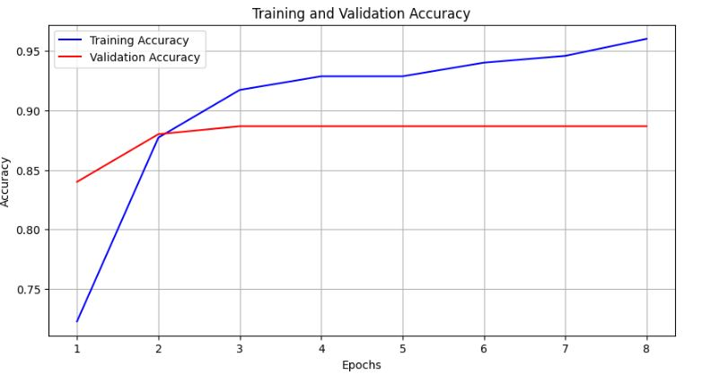

Figure B- 1: Training and Validation Accuracy for MLP

These results highlight a fundamental limitation of MLPs in this context: their inability to capture spatial dependencies within thermal image data. Unlike convolutional neural networks (CNNs), which are designed to exploit spatial structure, MLPs treat each pixel independently, discarding important spatial cues necessary for robust presence detection. As a result, while MLPs offer simplicity and fast training, their performance falls short in tasks requiring spatial awareness, such as interpreting thermal frames for human presence classification.

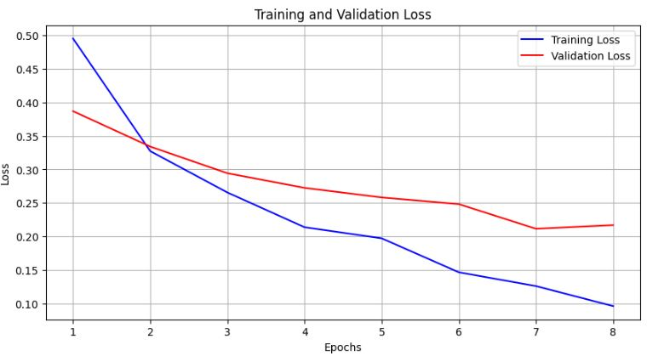

Figure B- 2: Training and Validation Loss for MLP

## Appendix C – Full-Resolution Graphs from Sensor Performance Evaluation

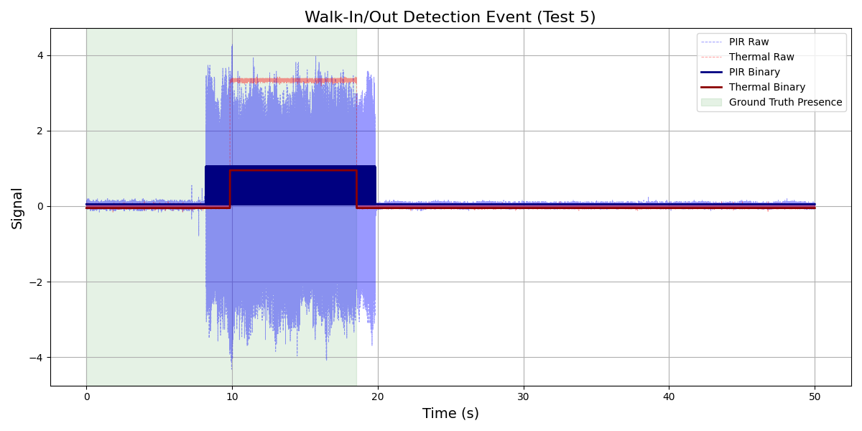

Figure C- 1: Walk-In/Out Detection Event (Test 5)

This appendix provides high-resolution signal trace plots from various sensor evaluation tests, including walk-in/out events and static presence scenarios. These visualizations complement the summary plots shown in the main text and allow for closer inspection of raw and binary signals from both PIR and thermal sensors. Each figure illustrates the system’s response during specific test conditions, highlighting differences in detection timing, stability, and signal behavior.

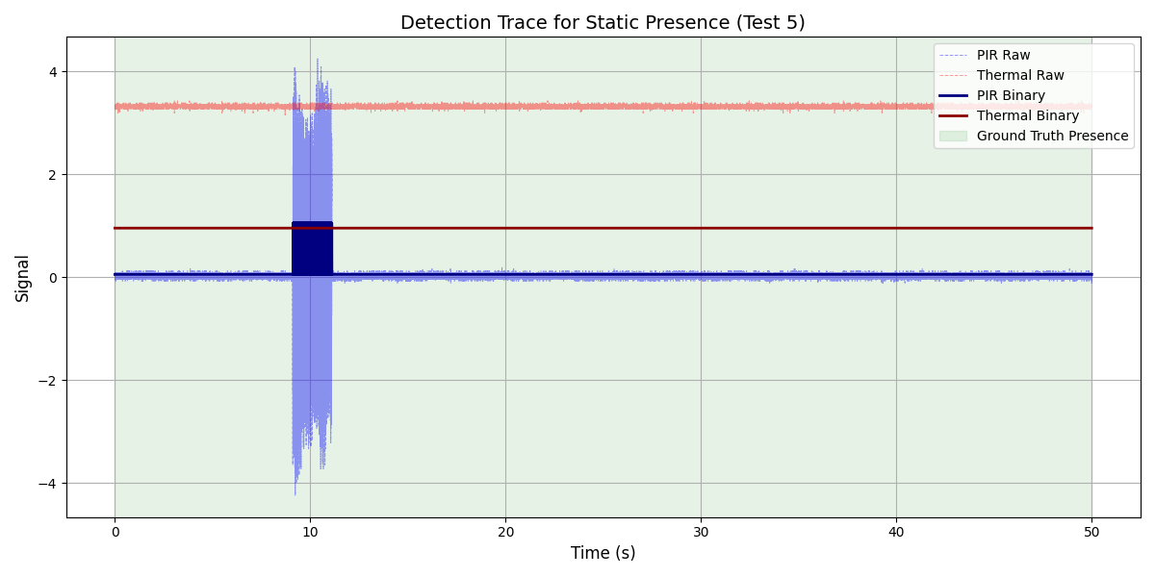

Figure C- 2: Static Presence Detection (Test 5)

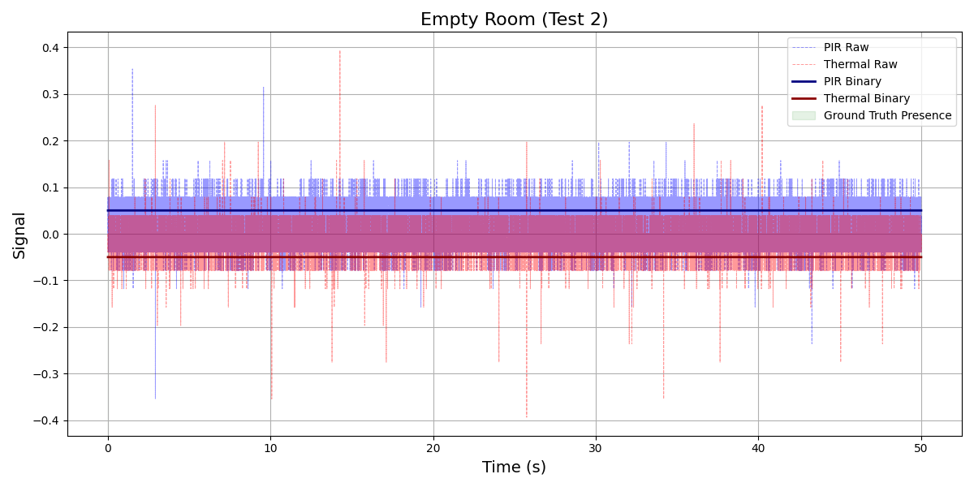

Figure C- 3: No Human Presence (Test 2)

## Appendix D – Frame-by-Frame Inference Outcomes on ESP32-S3 Using Thermal Input

This appendix presents the detailed inference outcomes from a real-time evaluation of the deployed quantized model on the ESP32-S3 microcontroller using live thermal sensor input below in Table D1. Each row in the table corresponds to a single frame classified during live operation and includes:

* The predicted class by the model (0: no presence, 1: presence),
* The ground truth (expected) class,
* And the resulting inference case (True Positive, False Negative, etc.).

The dataset includes a representative sample across various occupancy conditions, including full presence, partial presence, and absence. This tabular breakdown supports the quantitative performance summary presented in **Figure 33**, and substantiates the model's real-time accuracy and reliability under operational constraints.

Table D 1: Classification Results from Real-Time Thermal Inference on ESP32-S3

|  |  |  |  |
| --- | --- | --- | --- |
| **Observations** | **Predicted Class** | **Expected Class** | **Inference Case** |
| 1 | 1 | 1 | True Positive |
| 2 | 1 | 1 | True Positive |
| 3 | 1 | 1 | True Positive |
| 4 | 1 | 1 | True Positive |
| 5 | 1 | 1 | True Positive |
| 6 | 1 | 1 | True Positive |
| 7 | 1 | 1 | True Positive |
| 8 | 1 | 1 | True Positive |
| 9 | 1 | 1 | True Positive |
| 10 | 1 | 1 | True Positive |
| 11 | 1 | 1 | True Positive |
| 12 | 1 | 1 | True Positive |
| 13 | 1 | 1 | True Positive |
| 14 | 1 | 1 | True Positive |
| 15 | 1 | 1 | True Positive |
| 16 | 1 | 1 | True Positive |
| 17 | 1 | 1 | True Positive |
| 18 | 1 | 1 | True Positive |
| 19 | 1 | 1 | True Positive |
| 20 | 1 | 1 | True Positive |
| 21 | 0 | 1 | False Negative |
| 22 | 0 | 1 | False Negative |
| 23 | 0 | 0 | True Negative |
| 24 | 0 | 0 | True Negative |